**Indwelling Catheters-the Facts** 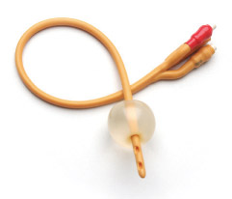

* Catheters are passed through the urethra into the bladder,OR can be inserted through a small hole in your abdomen.( which is initially performed as a small operation)
* They are held in place by a water filled balloon.
* They can be attached to a collecting bag or may have a valve attached to regulate outflow.

**GOOD reasons to need an indwelling catheter**

* **Post operative or when in hospital to monitor output.**
* **Damage to or blockage in urethra so that urine cannot drain properly.**
* **Surgical reason or surrounding organs or tissues need to be kept free from urine to heal properly.**
* **UNABLE to empty bladder due to a neurological reason .**

Long term urinary catheters are an invasive “ foreign body” which bear many long term risks to your well being . They should ONLY be considered if **ABSOLUTELY** clinically necessary, a” last resort “.They should be considered only if benefits outweigh the risks, and if the use of intermittent catheters is not possible.

**They can be dangerous** and the following facts need to be considered

* They cause a **permanent state** of bladder bacterial contamination,  which may lead to the use of unnecessary antibiotics,which leads to resistance and side effects.
* Approximately **3% of all patients** with a catheter **will develop bacteraemia**, which is a serious and possible life threatening blood infection .
* **20% -30%**of all hospital acquired infections start in the urinary tract –most of which started due to the patient having a catheter .
* Presence of bacteria can lead to changes in the urine which causes encrusting and BLOCKAGES .
* A blocked catheter can cause bypassing and leakage
* Catheters can cause **longterm trauma** to the delicate lining of the urethra,**chronic irritation** and increase the risk of **bladder cancer, and bladder stones** 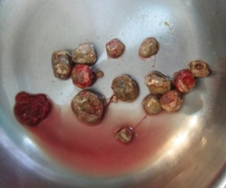
* Urine draining constantly into a bag stops the normal expansion and contraction of the bladder –so it loses its elasticity and function
* Catheters make you DEPENDENT on healthcare services , may reduce your ability to enjoy your social life and affect your self esteem

**The decision to live with a permanent catheter in the absence of any clinical indication should not be taken lightly.**

THERE *ARE however some* circumstances in which a longterm catheter is the only answer to a urological problem. If so, we will help you self manage the best we can to avoid some of the complications above .