Coordinate My Care (CMC)
How to join as a user
Quick-guide for staff working at Barnet and Royal Free Hospitals

- Complete short training video
https://www.coordinatemycare.co.uk/for-healthcare-professionals/training-viewing-creating-cmc-care-plans/
There are additional resources available in ‘clinical training’ section.
If you prefer to attend a webinar, see ‘booking and confirming training’
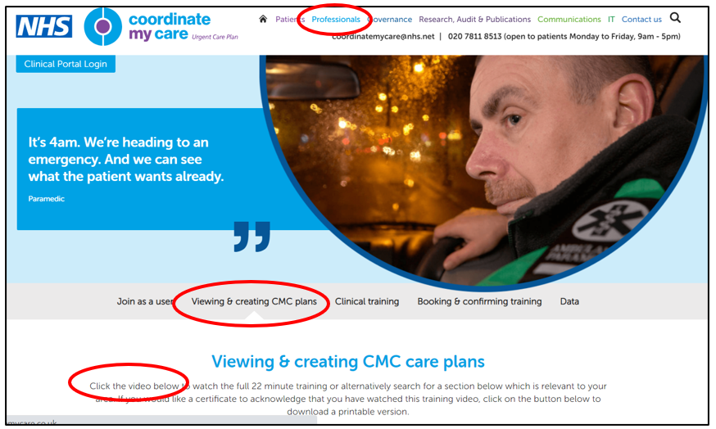

- Complete User Access Form (UAF) -> ‘UAF for staff with nhs.net email address’
https://www.coordinatemycare.co.uk/for-healthcare-professionals/become-a-user/
Your login details will be emailed to you!

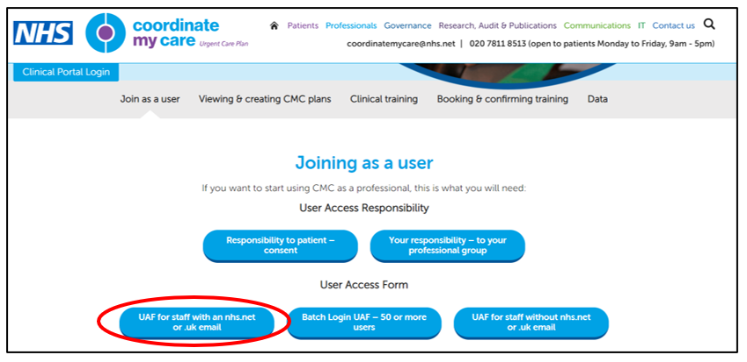

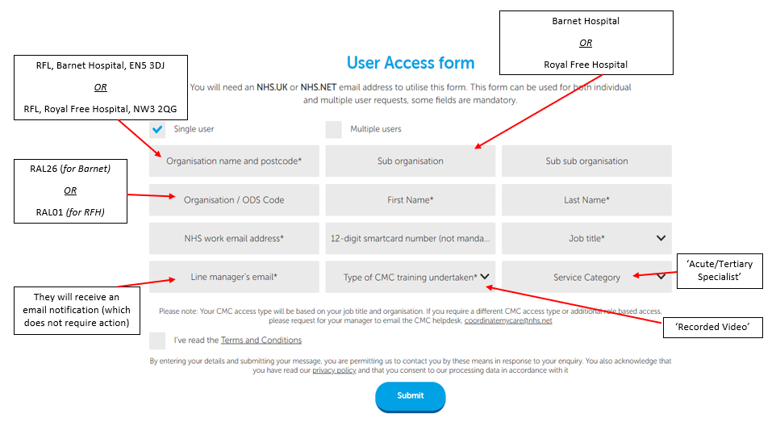

FAQS:
I forgot my password!
Email coordinatemycare@nhs.net

I have a CMC login but I have moved/am moving Trusts
Complete a new UAF form with details of new Trust or job role. Or email coordinatemycare@nhs.net

I want to make a CMC record with my patient – is their address covered by CMC?
CMC is widely available across London. Hertfordshire is not currently covered by CMC. If you are unsure, you may wish to use the following:
- https://www.coordinatemycare.co.uk/the-areas-we-cover/
- https://stephenkeable.github.io/ccg-lookup/

I’d like to give my patient and their family more information about CMC
There is a patient section on the website with information and videos, including information about myCMC. Leaflets are also available to print here.

