Page 12
Primary Care Trust information:
Making a comment, suggestion or complaint

Our Patient Advice and Liaison Service (PALS) will provide advice and support to service users, their families and carers. It also provides on-the-spot help to sort out any problem you may have.

PALS Department
Patient Experience Team
Sovereign Court
15-21 Staines Road
Hounslow
TW3 3HR
0800 953 0363

The PCT has access to interpreters who can speak other languages.
This leaflet can be made available in large print, Braille or on audiotape and a translation service is available.
Please contact 020 8973 3153.

NHS Direct
NHS Direct is a 24-hour confidential advice helpline staffed by expert nurses. Telephone 0845 4647. The helpline has access to interpreters who can speak other languages.

NHS Direct Online – this is an internet site which provides information about health services, conditions and treatment choices:
www.nhsdirect.nhs.uk

Produced by K Boyton RGN Continence Service HRCH (Nov 2013)

Prolapse Information

Integrated Continence Services



If you are registered with a GP in the London Borough of Richmond, this leaflet is for you…..

Hounslow and Richmond
Community Healthcare NHS Trust
180 High Street
Teddington
Middlesex
TW11 8HU
Tel: 020 8973 3000

How to contact your local Continence Service
You can contact the Bladder & Bowel Dysfunction Services (Continence Service) on:

020 8714 4086
If registered with a Richmond GP

020 86303296
If registered with a Hounslow GP

Administrative services operates Monday to Friday from 8.30am to 3.30pm.
Several of our clinicians work part time and spend most of their time in clinic.
Please always contact the service via administrative office numbers.

A discreet and private answering machine service is available when the office is unmanned or the telephone line is engaged.

For Richmond area:
Continence Service, Teddington Memorial Hospital, Hampton Road, Teddington, Middlesex, TW11 0JL, Fax: 020 8714 4162

For Hounslow area:
Continence Service, Brentford Health centre, Boston Manor Road, Brentford, TW8 8DS, Fax No. 8630 3110

What is genito -urinary Prolapse
Inside a woman's pelvis are the uterus, the bladder, and the lower bowel (rectum). Normally, these are supported and held in position by certain structures including ligaments and the muscles at the bottom of the pelvis (pelvic floor muscles).

What causes prolapse?

Prolapse occurs when these normal support structures are weakened and are no longer effective.
- The result is that one (or more) of the organs inside the pelvis drops down (prolapses).
- The organ(s) to drop down into the vagina. There can be different degrees of prolapse depending on how much, or how far, the organ(s) might have dropped down
- Sometimes, the prolapse can be so much that it causes the walls of the vagina, or the uterus (womb), or both, to protrude outside the opening of the vagina.

Page 11
Page 2

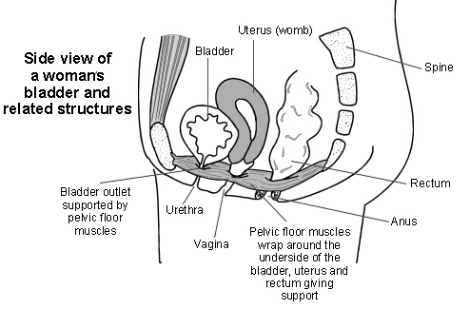
Page 10
Page 3
Ring Pessaries
These are made of flexible silicone and are usually ring shaped ( although there are many different shapes)
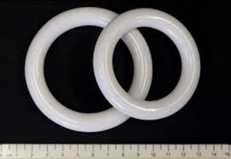They are initially inserted by a gynaecologist who will find the correct size for you. Subsequent changes are done every 6 months in either your GPs surgery or at a gynae clinic in the hospital.
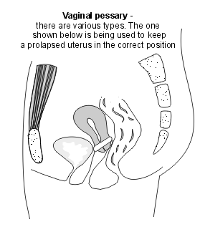They are a good solution for women who are unsuitable for a surgical procedure.

References
Patient.co.uk
Tim Peters and co.
www.oxfordgynaecology.com
www.shutterstock.com

What are the different types of prolapse?

Different types of prolapse can occur depending on which pelvic organ, or organs, might have dropped down into the vagina

Anterior (front) part of vaginal wall
- There can be prolapse of the urethra (the tube along which urine passes from the bladder to the outside) into the vagina. The medical term for this is a urethrocoele.
- There can be prolapse of the bladder into the vagina. The medical term for this is a cystocele.
- Or, both the urethra and the bladder can prolapse into the vagina at the same time. The medical term for this is a cystourethrocoele.This is the most common type of GU prolapse.
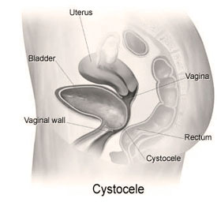
- Bowel symptoms (posterior wall prolapse) can include sensation of incomplete bowel emptying,or needing to push around perineum or vagina to defaecate.Needing to strain to pass a motion, or losing control of bowels/passing wind involuntarily.

What treatment is available
- Pelvic floor exercises to strengthen tone and prevent worsening of prolapse
- Oestrogen creams/vaginal tablets to relieve/soothe.
- Lose weight
- Treat constipation to remove the need to strain to open bowels.
- Vaginal pessaries ( see next page for more detail)
- Surgical intervention such as vaginal repair, hysterectomy or various operations to “lift “ the uterus/vagina . Many of these techniques involve “ mesh “ being used to strengthen the body’s own tissues . Any surgical procedure decided upon by a gynaecologist would be discussed in detail with you .

Page 4
Page 9

- You can have a prolapse and not notice any symptoms from it. ( possibly discovered when having a avginal examination for example)
- The feeling of a lump in your vagina or having a feeling of 'dragging' or something 'coming down'. You might be able to feel a lump
- Pain in your vagina, back or abdomen.
- Possibly discharge from your vagina
- Uncomfortable intercourse
- Symptoms are often worse after long periods of standing and they improve after lying down.

- URINARY symptoms ( anterior wall prolapse) leakage of urine when coughing/laughing/sneezing, Frequency , and urgency of the need to “go”.Feeling of incomplete emptying . Needing to push the lump back in order to wee properly. Poor flow of urine .
.

Middle part of the vaginal wall
- There can be prolapse of the uterus (womb) into the vagina. This is called a uterine prolapse and is the second most common type of GU prolapse.
- If a woman has had a hysterectomy (removal of the uterus), the end of the vagina that would normally attach to the cervix (the neck of the womb) is closed up during the operation. This now blind-end of the vagina is referred to as the vaginal vault. The vaginal vault can prolapse into the vagina. This is known as a vault prolapse.
- There can be prolapse of the pouch of Douglas (the space between the rectum and the uterus) into the vagina. The medical term for this is an enterocele. Loops of bowel may be present in the prolapse, enclosed within the prolapse.
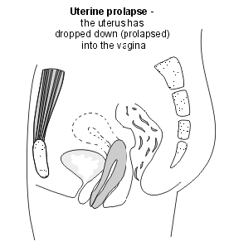
Page 8
Page 5

What are the symptoms

Prolapse affecting the posterior (rear) part of the vaginal wall
- There can be prolapse of the rectum (the back passage) into the vagina. The medical term for this is a rectocoele. This is the third most common type of GU prolapse.

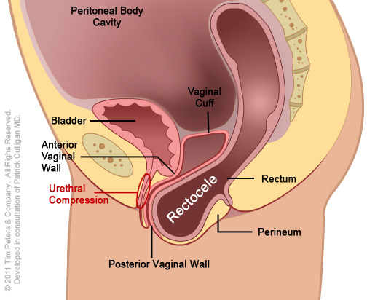
Number of causes lead to prolapse:
- Childbirth

During a vaginal birth there is excessive stretching of the ligaments, nerves and muscles (including the pelvic floor muscles) around the vagina. This stretching can damage them and make them weaker and less supportive. NOT everyone who gives birth develops a prolapse. It may be more likely after a difficult, prolonged labour, a forceps delivery, or if a woman gives birth to a large baby. It also becomes more likely the more times a woman has given birth.
- Increasing age

The chance of having a prolapse increases as a woman gets older. Reduced oestrogen hormone levels that occurs after the menopause affects the pelvic floor muscles and structures around the vagina, making them less springy and supportive.
- Increased abdominal pressure-eg pregnancy, overweight, constant coughing, heavy lifting, straining in chronic constipation.

- Other factors including post gynae surgery/congenital factors.

Page 6
Page 7

