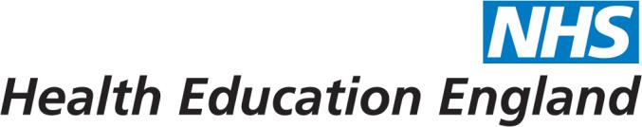
Programme Application form 2017

Name:

Position and grade:
Indicative level: NHS – Band 8C & D, and Band 9; managers, clinical and specialist staff with managerial responsibilities. University – professor; associate professor; head/deputy head of department or division and above; heads/deputy heads of professional services; leaders of research groups; leaders of health and social care programmes. Local Government – assistant director; director, deputy/departmental head; Public Health specialists and managers.

Employer organisation:

Address (email and postal):

Line manager’s name and email address Please note that you must have your line manager’s agreement to be released for the 14 days of the programme ( modules and project group meetings) and you have to be committed to attending all the sessions:

In no more than 150 words per question please respond to the following questions:

Have you had any formal management or leadership training? If yes, briefly indicate level, length and the topics you have covered.

What are your career aspirations in the short and longer term and how will this programme support them? In what way will this programme contribute to performance in your current role?

Do you have any experience of working across boundaries, organisational or disciplinary? Which organisations or disciplines does this involve? What do you see as the major challenges?

How did you find out about this programme?

Please also attach or paste a copy of your CV including:

- Current post, grade, time in current post and organisation
- Recent job history
- Qualifications

Please send your completed application form to Kitty Grew at kitty.grew@nhs.net (tel. 020 7188 7188 ext. 57042) by Monday 13th November 2017.

