My catheter
Take to all
appointments
for your
catheter
passport

Looking after my urinary catheter

This is a shared record between the patient and the healthcare professional

Your details
NAME ADDRESS

POSTCODE

Contact us
If you have any questions or concerns about your catheter, please contact the appropriate healthcare professional.

Who should I contact?

Able to visit general practice and see practice nurse / GP / nurse specialist
Unable to leave house and have a district nurse

Call your surgery / practice nurse / nurse specialist

Call your district nurse

If you need to see someone out of hours
Call SELDOC – 020 8693 9066

Your important contact numbers

PRACTICE NURSE DISTRICT NURSE
CLINICAL NURSE SPECIALIST GP
HOSPITAL TEAM

BLADDER AND BOWEL SERVICE

2 My catheter passport

Contents

Personal information 2

Patient information 4
What is a urinary catheter? 5
Having a catheter inserted 6
Looking after your catheter 8
Changing your catheter 10
Are there any alternatives to a catheter? 10
Are there any risks with having a catheter? 11
Self-help – what if I have problems? 11
When should I ask for help? 13

Catheterisation records
(to be completed by your healthcare professional) 14

Problems and follow-up actions 26

My catheter passport 3

For the patient

Introduction

This passport will help you to understand what a catheter is, why you may need one inserted, and how you should look after it. It also has space for healthcare professionals to record important information about your catheter, and for you both to record decisions that you’ve made together about your care.

Make sure you keep this record of your catheter and have it with you whenever you have your catheter changed, so your
lead healthcare professional (this could be your GP / practice nurse /
district nurse) can update your catheter details.

Why do I need a catheter?

There are many reasons why people need a catheter: your bladder may not be able to contract on its own to empty itself, or you may need it for other health-related problems.

You may need a catheter for a short period, such as before or after surgery, or you may need it permanently.

The reason you require a catheter is:

Long-term n
Short-term n

Your healthcare professional will explain to you in detail why you need to have a catheter, how long you may need it for, and what type is best for you. They will also ask you to give your verbal consent to have a catheter. Please make sure you ask any questions you have at this time.

If your catheter is short-term, an appointment for a trial without catheter
(TWOC) should have been made for you in:

weeks at

(For the healthcare professional: if you do not know date and time please write
Outpatient Dept details for patient to follow up)

4 My catheter passport

What is a urinary catheter?

A catheter is a hollow, flexible tube that drains urine from your bladder. A urethral catheter drains through your urethra (the tube through which urine passes). A suprapubic catheter drains through a channel in your abdomen wall. See the diagrams below. There are other ways to fit catheters, but these are not discussed in this passport.

Female

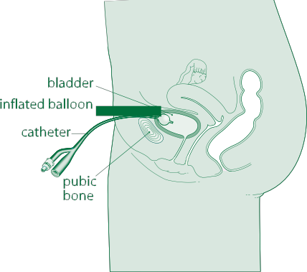
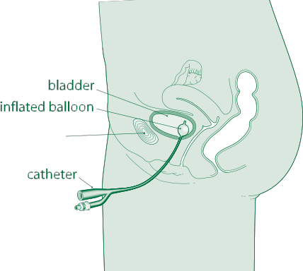
Suprapubic catheter in place Urethral catheter

Male

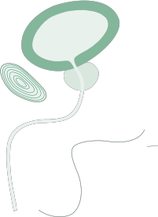
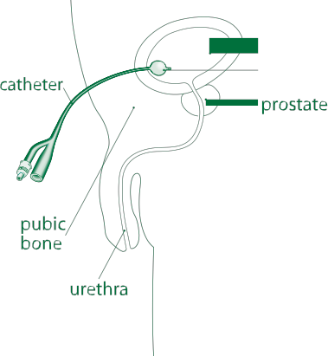
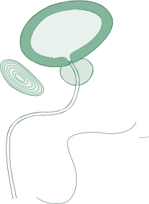
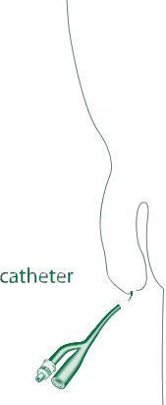
Suprapubic catheter in place Urethral catheter

Images used with kind permission from BARD Ltd.

My catheter passport 5

Having a catheter inserted

The way that your catheter is inserted will depend on the reason and length of time that you need a catheter.

Once the catheter is in place, a balloon is inflated inside your bladder to prevent it from falling out. Your catheter will be attached either to a leg bag or a catheter valve.

A leg bag is a simple drainage bag to collect your urine. This is strapped
to your leg. If you are bed bound, it may be a belly bag or a two litre bag rather than a leg bag. It needs to be emptied when the bag is three- quarters full.

With a catheter valve, your urine collects in your bladder, which can be
emptied at regular intervals by releasing the valve.

Both options will be explained to you, as well as how to operate them. The bag or valve needs changing as recommended by the manufacturer’s instructions (this is usually once per week). It is important that you do not change them more often, as this raises the risk of infection. Write the date on the bag when you change it.

Securing your catheter

Occasionally, straps to secure the leg bag to your leg may not be appropriate. If this is the case, your lead healthcare professional will discuss alternatives with you. Your healthcare professional will also advise you of the most appropriate device to secure your catheter.

6 My catheter passport

At night

When going to bed, you should attach the leg bag or valve to a larger bag, which will drain freely overnight to collect the urine. If you are prone to swollen legs or have poor circulation, loosen the velcro straps on the leg
bag so that they do not constrict the blood flow to your leg. In shared living circumstances (such as hostels, shared housing, care homes etc.) the risk of infection increases, so the bag should be single use, and disposed of after each night.

If your bag is re-usable: In the morning, disconnect the night bag, empty it, wash through with soapy water and store it in a clean place until you reconnect it. This bag should also be changed according to the manufacturer’s instructions.

You will be given supplies when you leave the hospital and be told how to get further products.

Will I have any pain?

The catheter may feeli uncomfortable at first. You could experience spasms
(sudden contractions of your muscles) which can be painful, make you feel like you need to pass urine, and cause some urine to leak around the catheter. If you have spasms:

●● try repositioning the catheter so that it is not pulling on your bladder
●● try to relax and do not strain or try to push the catheter out
●● drink as advised on page 8 and avoid bladder irritants: caffeine
(including coffee, tea, green tea), citrus fruits and juice, artificial sweetener and fizzy drinks.

If this feeling lasts, take painkillers to ease the pain. If the pain persists, contact your healthcare professional for further advice.
You may find it uncomfortable when the catheter is removed, but it should not be painful.

My catheter passport 7

Looking after your catheter

Having a catheter should not prevent you from doing everything you were doing previously.

Hygiene

Before and after touching your catheter you must always wash your hands thoroughly.

You can bathe or shower as normal with a catheter. If you have a leg bag, do not disconnect it, as this could introduce an infection. If you are not able to have a bath or shower, wash the area where the catheter enters your body twice a day. Wash the area using downward strokes from where it enters the body. Again, this is to help prevent infection. Do not apply talcum powder or cream to the area as this may increase the risk of infection.

Your diet and fluids

It is important to eat a balanced diet of fruit, vegetables and fibre to avoid constipation (difficulty or pain emptying your bowels). If your bowel is full, which happens when you are constipated, it can press on your bladder, reduce urine drainage and may block the catheter.

Drinking is very important when you have a catheter. Try to drink at least one-and-a-half to two litres per day (six to eight large glasses of fluid), unless you have been otherwise advised by your healthcare professional. This will help prevent infections and flush out any debris in your bladder.

Drinking alcohol will not affect your catheter. However, if you are taking certain medicines or recovering from surgery, your doctor may advise against drinking alcohol. This depends on your individual circumstances. Please ask your healthcare professional if you are uncertain.

8 My catheter passport

Can I work and exercise as normal?

You can return to work, exercise or go on holiday as soon as you feel able to and your doctor has said you are fit enough to do so.

What about sex?

For women, you can leave the catheter in place or pull it forward and tape
it on to your stomach. You can use lubricating jelly if you need to – it will not damage the catheter.

For men, you can leave the catheter in place, but once you have an erection, fold it under your penis and apply a condom over your penis and the catheter. You can use lubricating jelly if you need to – it will not damage the catheter.

Always wash around your catheter with mild soap and water before and after sex. For those with a more active sex life, you can consider asking for a suprapubic catheter to be inserted. Please speak to your healthcare professional if you wish to consider this.

How do I dispose of used catheter bags?
●● Empty the contents into the toilet.
●● Double wrap the bag (either in newspaper or a plastic bag).
●● Place into your household waste bin.

My catheter passport 9

Changing your catheter

Catheters can stay in place for two to 12 weeks before they need to be changed. Your healthcare professional will change your catheter as necessary, unless you are due to have it permanently removed.

If you have a suprapubic catheter, you may need to come back to hospital the first time it is changed. After this, your healthcare professional can change it.

You will be referred to the appropriate healthcare professional when you leave hospital so that you have a point of contact when you are at home.

If you have a new or long-term catheter, prophylactic antibiotics (taken as a precaution against infection) are not required unless you develop symptoms that may require antibiotics. Some patients may require antibiotics when their catheter is being changed, you will be advised of this by your healthcare professional.

Are there any alternatives to a catheter?

There are many reasons why a catheter may need to be inserted. The team caring for you will explain if there are any alternatives for you.

If you are male and have been catheterised for continence issues an external sheath catheter (also known as a condom catheter) can be used. This is fitted over the penis and connected to a drainage bag.

Intermittent self-catheterisation

You may be able to perform intermittent self-catheterisation. This involves passing a catheter into your bladder to drain your urine, then removing the catheter and discarding it. We will give special training on how to do this, so ask the medical team if you think this is something you would like to do instead.

Bladder and Bowel Foundation
For more information on your catheter, contact the Bladder and Bowel Foundation. Please call their helpline on 0845 345 0165 if you require further advice and/or support, or visit their website for further information: www.bladderandbowelfoundation.org

10 My catheter passport

Are there any risks with having a catheter?

You may have a slightly increased risk of developing a urinary tract infection (UTI). Your doctor / nurse will discuss any risks with you before asking for your consent to insert the catheter. Following the guidance on your diet and fluids (on page 8) will help to reduce the risk of developing a UTI.

What is a urinary tract infection?
A catheter can sometimes allow bacteria (germs) to enter the body.
This can cause an infection in the urethra or bladder. This type of infection is known as a urinary tract infection (UTI). Some of the common symptoms of a UTI include:

●● passing bad-smelling cloudy urine
●● high temperature (fever)
●● vomiting
●● stomach pain.

Contact your GP / district nurse as soon as possible if you think you have a UTI.

Self-help – what if I have problems?

Blood in your urine

When the catheter is first inserted or changed, your urine may have blood in it. Drink extra fluids to flush the blood out. If this continues, you should contact your lead healthcare professional.

If the catheter is accidentally pulled on or pulled out it may cause bleeding. To prevent this, please make sure that it is secured properly. If this does happen, contact your healthcare professional.

My catheter passport 11

Leaking catheters

Sometimes the catheter can leak around the entry site. If this happens:

●● make sure the tubing is not blocked or kinked (bent)
●● move the drainage bag below the level of your bladder
●● make sure you are not constipated.

Do not apply tape to keep the bag attached to the catheter. If you are experiencing leakage, you may need to change the bag you are using to a different type with a different connection. Your healthcare professional can advise you on this.

Blocked catheters

If your catheter becomes blocked you should:

●● empty the drainage bag, so you can better see if it begins to drain
●● lift the drainage bag above the level of the bladder then lower it again, which can release any suction of the bladder wall
●● do a catheter washout (if you have received instructions on how to carry this out).

If the above does not resolve the issue, please contact your lead healthcare professional (see contact details on page 2).

Soreness

If you experience soreness, ensure your catheter retention strap is correctly fitted, as well as your leg straps if wearing a leg bag.

Cloudy, bad-smelling, thick urine

Your urine should be light yellow in colour (although some medicines may discolour urine) and should flow freely. If your urine becomes cloudy,
smelly or thick, check that you are drinking enough and increase your fluid intake accordingly.

12 My catheter passport

Faecal incontinence

If you have difficulty controlling your bowels, you may be at a higher risk of contracting a UTI. If you are worried about this, please speak to your healthcare professional to find out how you can avoid it.

When should I ask for help?

You should know what is normal for you. If you experience symptoms that
are unusual for you and have followed the steps in the self-help guide, please contact your healthcare professional.

Common reasons to seek help:

●● no urine drains from your bladder for four hours
(and you are drinking as normal)
●● you are experiencing pain
●● urine is leaking around the catheter.

Your healthcare professional or out-of-hours service will be able to offer advice. Please contact your hospital team or go to A&E if your catheter
is blocked and you are unable to contact your healthcare professional within four hours. All other catheter issues can wait until your healthcare professional is available.

If you have a suprapubic catheter and it falls out, contact your healthcare professional immediately. Urethral catheters need to be replaced less urgently. If you are experiencing no urine drainage and some abdominal discomfort, seek help immediately.

If you are concerned about anything, please ask a healthcare professional
(see contact details on page 2).

Catheterisation records

This section is for your healthcare professional to fill in.

Catheterisation records

All healthcare professionals should record details of urinary catheterisation in the sections below, as well as the appropriate nursing / medical records. Please use pages 17–25 to record any catheter changes. Pages 26–30 should be used by both the patient and healthcare professional to document any problems and subsequent interventions.

Completion of the booklet will enhance continuity of care for the patient between community and hospital settings.

Catheterisation details

Reason for catheterisation
Type of catheter | Long-term n●●●●Short-term n●●●●TWOC n●●●●  Suprapubic n●●●●Urethral n●●●●
Date of first catheterisation
Catheter type and size

Drainage system used and ordering codes

Leg bags Night bags Catheter valves

Any problems experienced during catheterisation

Please document any important infections information below and whether prophylactic antibiotics are given.

Please refer to the Trust guideline for information regarding catheter management:

GSTT: Go to Clinical GTi, click on ‘search clinical guidance’ (below the search box) and enter “urinary catheterisation in adults”.

KCH: Go to the NICE website (or a search engine) and search for “Infection: Prevention and control of healthcare-associated infections in primary and community care”.

Date of positive result for MRSA in the urine or
other significant infections

Known allergies
Antibiotic given at insertion? | Yes n●●●●No n
Antibiotic required at every catheter change?  Name (printed)  Date | Yes n●●●●No n

For the healthcare professional

Record of catheter changes
Date
Type of catheter
Size
Batch number
Expiry date
Antibiotic given? | Yes n●●●●No n
Reason for catheter change
Problems
Date of next planned change
Name (printed)

ADD STICKER

Date
Type of catheter
Size
Batch number
Expiry date
Antibiotic given? | Yes n●●●●No n
Reason for catheter change
Problems
Date of next planned change
Name (printed)

ADD STICKER

ADD STICKER
Date
Type of catheter
Size
Batch number
Expiry date
Antibiotic given? | Yes n●●●●No n
Reason for catheter change
Problems
Date of next planned change
Name (printed)

Date
Type of catheter
Size
Batch number
Expiry date
Antibiotic given? | Yes n●●●●No n
Reason for catheter change
Problems
Date of next planned change
Name (printed)

ADD STICKER

ADD STICKER
Date
Type of catheter
Size
Batch number
Expiry date
Antibiotic given? | Yes n●●●●No n
Reason for catheter change
Problems
Date of next planned change
Name (printed)

Date
Type of catheter
Size
Batch number
Expiry date
Antibiotic given? | Yes n●●●●No n
Reason for catheter change
Problems
Date of next planned change
Name (printed)

ADD STICKER

ADD STICKER
Date
Type of catheter
Size
Batch number
Expiry date
Antibiotic given? | Yes n●●●●No n
Reason for catheter change
Problems
Date of next planned change
Name (printed)

Date
Type of catheter
Size
Batch number
Expiry date
Antibiotic given? | Yes n●●●●No n
Reason for catheter change
Problems
Date of next planned change
Name (printed)

ADD STICKER

ADD STICKER
Date
Type of catheter
Size
Batch number
Expiry date
Antibiotic given? | Yes n●●●●No n
Reason for catheter change
Problems
Date of next planned change
Name (printed)

Date
Type of catheter
Size
Batch number
Expiry date
Antibiotic given? | Yes n●●●●No n
Reason for catheter change
Problems
Date of next planned change
Name (printed)

ADD STICKER

ADD STICKER
Date
Type of catheter
Size
Batch number
Expiry date
Antibiotic given? | Yes n●●●●No n
Reason for catheter change
Problems
Date of next planned change
Name (printed)

Date
Type of catheter
Size
Batch number
Expiry date
Antibiotic given? | Yes n●●●●No n
Reason for catheter change
Problems
Date of next planned change
Name (printed)

ADD STICKER

ADD STICKER
Date
Type of catheter
Size
Batch number
Expiry date
Antibiotic given? | Yes n●●●●No n
Reason for catheter change
Problems
Date of next planned change
Name (printed)

Date
Type of catheter
Size
Batch number
Expiry date
Antibiotic given? | Yes n●●●●No n
Reason for catheter change
Problems
Date of next planned change
Name (printed)

ADD STICKER

ADD STICKER
Date
Type of catheter
Size
Batch number
Expiry date
Antibiotic given? | Yes n●●●●No n
Reason for catheter change
Problems
Date of next planned change
Name (printed)

Date
Type of catheter
Size
Batch number
Expiry date
Antibiotic given? | Yes n●●●●No n
Reason for catheter change
Problems
Date of next planned change
Name (printed)

ADD STICKER

ADD STICKER
Date
Type of catheter
Size
Batch number
Expiry date
Antibiotic given? | Yes n●●●●No n
Reason for catheter change
Problems
Date of next planned change
Name (printed)

For the patient and the healthcare professional

Problems and follow-up actions

The section below is a space for you to record any problems you have with your catheter and the actions that you agree with your healthcare professional.

Record any problems you have experienced or any issues you would like to discuss. When you visit your healthcare professional, discuss the problem and agree together how this will be resolved. The actions should be recorded as well.

Date
What problem would you like to discuss with your healthcare professional?
Joint agreed action
Name (printed)

Date
What problem would you like to discuss with your healthcare professional?
Joint agreed action
Name (printed)

Date
What problem would you like to discuss with your healthcare professional?
Joint agreed action
Name (printed)

Date
What problem would you like to discuss with your healthcare professional?
Joint agreed action
Name (printed)

Date
What problem would you like to discuss with your healthcare professional?
Joint agreed action
Name (printed)

Date
What problem would you like to discuss with your healthcare professional?
Joint agreed action
Name (printed)

Date
What problem would you like to discuss with your healthcare professional?
Joint agreed action
Name (printed)

Date
What problem would you like to discuss with your healthcare professional?
Joint agreed action
Name (printed)

Date
What problem would you like to discuss with your healthcare professional?
Joint agreed action
Name (printed)

For staff
useful contact information

If the patient does not have follow-up care arranged, or if you require advice, please contact the relevant service or individual below.

Guy’s and St Thomas’ staff
Bladder and bowel service for patients with chronic medical conditions and those aged 65+ and younger patients (also for TWOC). Call the continence nurse specialist for advice or to organise an appointment on
020 7188 2083.

King’s staff
King’s referrals need to be discussed with the King’s urologists prior to booking into TWOC clinic.

Urogynaecology will refer TWOC patients known to them. Please call on
020 3299 3568 to make an appointment.

Community staff
For patients living in Southwark or Lambeth who are not under specialty services above, refer to community services for TWOC, for clinic appointments. Contact customer services on 020 3049 4040.

If the patient is out of area and requires community TWOC, contact GP
and district nurse.

SELDOC
SELDOC provides urgent medical care for patients in Southwark and Lambeth out of hours (6.30pm to 8am). Please call 020 8693 9066 for further advice.

Leaflet Number:4123NER1
Date published July 2015
Review date July 2018
© 2 015 Guy's and StThomas' NHS Foundation Trust

