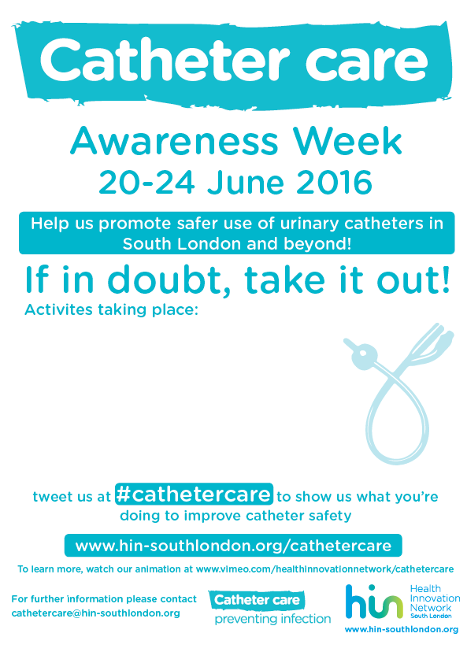

**To learn more about our project, please visit:**[**https://healthinnovationnetwork.com/projects/catheter-care/**](https://healthinnovationnetwork.com/projects/catheter-care/)

**Tweet us @hinsouthlondon with #cathetercare to show us what you’re doing to improve catheter safety.**

**“If in doubt, take it out!”**

**This Catheter Awareness Week, join [Organisation]**

**In the following activities:**

**[Activities]**

**15-21 June 2020**



**Awareness Week**