Guide for Acute Staff

Guide to Implementing the eRedBag Pathway

Contents

**1. Aim of this user guide 3**

**2. About the eRedBag 3**

**3. Benefits of the eRedBag 4**

**4. Where can the eRedBag be found? 6**

**5. Setting up a steering group 6**

**6. Further recommendations 7**

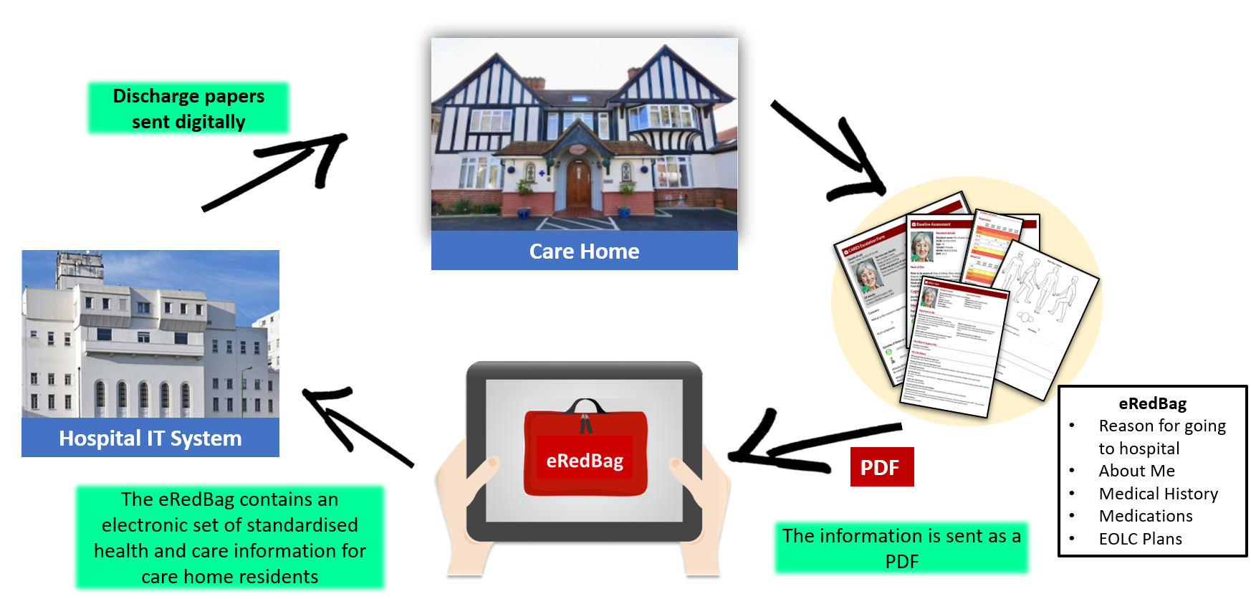

***Mobilisation Lead:***

***Please review this guide and edit it to ensure it is relevant for your rollout, then delete this box.***

**Date of publication: November 2022**

**Feedback on the eRedBag from users:**

**“Getting hold of and finding Red Bag information can be hard, so being able to find and access typed info electronically is very helpful, particularly as this helps with understanding functionality… ‘Are they usually confused, what do they usually eat and drink?’ … All these things are important for us to consider holistically.”**

**Acute Medical Unit, Doctor**

**“The eRedBag made a massive difference to this patient’s care so I would recommend it to anybody”**

**Lead Lung Cancer Clinical Nurse Specialist**

**“The eRedBag is very helpful. We look at the e-Docs folder when the care home resident comes in…it helps with nursing care… otherwise the doctor has to call the care home.”**

**Emergency Department Nurse**

**“With the eRedBag system there are only a few specific bits of information we need to add, the vital signs for example and the reason for the hospital transfer. Then we just press print and the eRedBag goes straight to the hospital. It saves us time because there is far less administration involved and the hospital now no longer calls us for information because it’s all there in the eRedBag.”**

**Care Home Manager**

## Aim of this user guide

This User Guide provides guidance and advice to Acute Trust staff on how to implement the eRedBag in their Trust. It describes the benefits, how to roll out, communicate and promote the eRedBag. Learning has come from a two-year pilot and proof of concept in South West London. The guide is aimed at senior staff and leaders with responsibility for rolling out the eRedBag in their Trust to support successful implementation.

## About the eRedBag

When a care home resident needs to go to the Emergency Department (ED), a **physical Red Bag** is packed with the resident’s personal belongings as well as a paper copy of the resident’s health and social care information. The Red Bag travels with the resident in the ambulance and moves with them throughout the ED and hospital stays and returns to the care home with the resident.

The eRedBag is an electronic version of all the paper documents contained in the physical Red Bag. Care home residents’ physical Red Bags will still travel with the patient but there will also be an eRedBag automatically accessible on the electronic patient record (EPR) within your hospital’s electronic system. On discharge, the Discharge Summary will be accessed digitally by the care home. This is in progress with the aim to be completed by the end of 2022.

Information within the eRedBag conforms to the Professional Records Standards Body (PRSB) standards. There are two revised [PRSB Standards](https://theprsb.org/standards/carehometohospital/) approved in 2020, which are relevant to the eRedBag:

* Transfer of information for urgent referral from care homes to hospital
* About Me

These standards describe the exact data items that must be transferred with a care home resident. In terms of groups of items, the eRedBag contains:

* Details of patient, preferred name to be called by, care home (including secure email address), GP and next of kin
* CARES Escalation Form – the symptoms observed, the concerns noted, and actions taken by the care home
* Medical history, medication (MAR) and vital signs observations (if available)
* Body map, including pressure sores
* CMC plan, Advanced Care Plan and DNACPR if any
* Reasonable adjustments and any impairments
* About Me form, personal preferences, end of life wishes
* Safeguarding, legal information and risks
* Additional support plans

Please refer to the ‘Dummy eRedBag’ which contains a test patient’s eRedBag. This shows how the pdf is likely to look. The test patient’s document also contains additional non-mandatory items such as a photo of the person and social information relating to care preferences.

**Why do we need an eRedBag?**

Previously:

“Paperwork can get misplaced, or not be there, or it can be difficult to understand the handwriting”

Then:

“Having an eRedBag on the system would be so helpful – when we get a pre-alert from the ambulance service we can prepare, knowing the medical problems, allergies and special care plans needed”

Now:

“The eRedBag is very helpful. We look at e-Docs folder when care home residents come in – that helps us as information is usually missing. Even with the physical Red Bag, the information is not always there. eRedBag helps with nursing care. Otherwise, the doctor normally has to call the care home

## Benefits of the eRedBag

The eRedBag has many benefits to individuals and partners across the health and care pathway. For acute staff, as demonstrated below, the key benefit is easy access to information to support decision-making. For acute trusts, the eRedBag is expected to reduce the number of people admitted to hospital from ED (Non-Elective Admissions (NELs)). Having information electronically available means more effective and efficient assessment in the Emergency Department. In addition, trials have indicated a reduction in overall length of stay (LOS) through more timely care and treatment, and quicker and safer discharges. This increases capacity and reduces the risks of Hospital Acquired Infections and deconditioning for patients from care homes.

The eRedBag benefits to hospital staff include:

* Quicker access to information to support decision-making
* reduced time on administration
* Improved communication across teams
* Access to reliable information that is up to date and of consistent quality
* Quicker, smoother and safer discharges
* A more secure means of transmitting information leading to fewer potential information governance (IG) breaches

The table on the next page lists some the benefits that accessing information in the eRedBag can bring to a range of health professionals.

**Watch the eRedBag** [**Video**](https://www.youtube.com/watch?v=YFeR2o6lqvo&feature=youtu.be) **(1 min:53 seconds long) - explaining how the eRedBag can help clinicians with providing better patient care.**

|  |  |  |
| --- | --- | --- |
| Clinical Team | The eRedBag provides | Benefit |
| ED Staff | Name that person prefers to be called by, current health concern, why they have been admitted and medical history. | Supports timely treatment  decision-making within ED and helps determine whether the person requires full admission |
| Medical Assessment Unit (MAU) Staff | Medical information contained in the documents, particularly the medication administration chart | Ensures that hospital teams are aware of existing medical problems that are not relevant to this admission and do not require further investigation/treatment |
| Ward Nursing Staff | The person’s usual level of function across activities of daily living, any identified health/safety risks e.g. falls, malnutrition. ‘About Me’ information enables hospital staff to get to know the person | Facilitates discussion as to whether the person is ‘back to baseline’ and therefore safe to discharge. |
| Ward Doctors | Information on existing medical problems that are not relevant to this admission and do not require further investigation/treatment. | Enables safer decision-making regarding treatment decisions. |
| Pharmacists | Medicines administration record (MAR chart), list of allergies. | Enables safe and effective prescribing of medicines whilst in hospital. Prior to discharge medicines reconciliation occurs to identify whether any changes have been made whilst in hospital. |
| Physiotherapists and Occupational Therapists | Information regarding the person’s mobility and what level of support/equipment they need. | Enables a baseline understanding of need in order to identify whether the person has changed in this respect and requires further intervention |
| Speech and Language Therapists | Information regarding the  integrity of the person’s swallowing and whether they have any dysphagia management needs, as well as contact details for the community SLT. | Enables a baseline understanding of need in order to identify whether the person has changed in this respect and requires further intervention |
| Discharge flow coordinators | Contact details for care home to agree and arrange discharge. | Assurance that discharge information will be viewed by care home staff |
| Dieticians | Information regarding the dietary needs of the person and what level of support/equipment they need, contact details for the community | Enable a baseline understanding of need in order to identify whether the person’s needs have changed and require further intervention. |
| Clinical site managers | Information that patient is from a care home and contact details for the home | Enables discussions to be had if the hospital is on ‘black alert’ and needs to create additional capacity. |

## Where can the eRedBag be found?

***<The Mobilisation Lead needs to update this section to align with the particular hospital system used in the area>***

The eRedBag can be found by acute staff in different ways depending on the particular EPR system in use. In general, it can be accessed by finding the patient in the local electronic patient record and looking in the correspondence folders as it is a ‘referral from care home to hospital’ record.

## Setting up a steering group

To support the successful implementation of the change to people’s working style, it is important to set-up a ‘steering group’, or equivalent, to oversee the change and delivery of the eRedBag project in the Trust. The eRedBag steering group needs to consider how to communicate that the eRedBag is now live, how to monitor implementation (such as, how often it is being accessed) and how to decide what improvements need to be made to the change process.

The steering group needs to include a wide group of hospital staff with senior staff leading the group and should reflect the pathway that care home residents take through the hospital. We would suggest:

* Director Level Senior Executive to sponsor the project and chair the meetings
* Chief Clinical Information Officer
* A senior clinician from Geriatrics / Older Adult health
* The current hospital Red Bag Operational Lead (if the post exists)
* A wide range of staff, including ED staff, OTs, discharge nurses, physiotherapists, pharmacists, ward nurses
* Communications Lead
* Tech Lead
* Data Protection Officer or Data Protection Lead

Action Plan for promoting the eRedBag

The steering group needs to agree an action plan for promoting the eRedBag – this may include:

* Frequency of steering group meetings and membership
* How often eRedBag audit data will be reviewed and by whom
* Communications plan – what methods to use and who will be involved
* Departmental and internal network promotions and rollouts

Using audit data and flag systems

1. The steering group needs to consider what data and flag alert systems are required to monitor the success of the eRedBag.
2. There could be an easy way to set a flag alert on your electronic patient record (EPR) system when a care home resident comes to hospital, whether they have a physical Red Bag and whether the eRedBag is on the system
3. The steering group needs to review data on access/click-rates for the eRedBag to understand how often eRedBag is available on EPR, who opens it and how often it is being accessed
4. If the steering group finds that eRedBag documents are not being accessed, it must consider why this might be the case or whether there are any patterns, for example more promotion may be needed with certain staff teams

## Further recommendations

Some additional recommendations include:

1. creating some Champions and Ambassadors – you may already have Red Bag champions, who can be your eRedBag champions. Champions and ambassadors in every part of the hospital can really help spread the message, from OTs to pharmacists, junior doctor to dieticians.
2. championing ‘user stories’ to describe what a difference the eRedBag has made to a patient’s care, and capturing stories from your own staff before launch
3. promoting via your networks – ask each department and clinical lead to spread the message within their networks. Consider Allied Health Professionals, Nursing, Community Health teams
4. advertising with physical tags as a reminder – magnets, stickers, posters, pens – they all help spread the message – “The eRedBag is now live on EPR”
5. promoting via e-communication - newsletters, WhatsApp groups, email signatures, screensavers.
6. riding on the success of previous internal campaigns – your communications and transformation teams will know what works best in your hospital. Use their expertise to guide you.
7. using techniques such as Ward walk-rounds, study days and team meetings
8. setting up a dummy care home resident on your EPR and attaching a dummy eRedBag on it so staff can access it and review before going live

For more information on the eRedBag Pathway, please contact [SWLCareHomes.eRedBag@swlondon.nhs.uk](mailto:SWLCareHomes.eRedBag@swlondon.nhs.uk)

Acknowledgements

We would like to acknowledge and thank the following organisations for their ongoing commitment to this project:

