Guide for Care Software Providers
Achieving the eRedBag Standards

Contents
1. Aim of this user guide 2
2. Introduction 2
3. Why meeting the standards is important 2
4. eRedBag solution 2
5. eRedBag implementation steps 3
6. Supporting your users / customers 4
7. Going forward 4

Date of publication: July 2022

Aim of this user guide
The purpose of this guide for Care Software Providers is to describe the steps required for a software provider to meet the eRedBag standards and send an eRedBag.

Introduction
The eRedBag project is a pioneering project to integrate Health and Social Care IT systems. There is a big drive for better interoperability between Health and Care services to support people in their journey through the various services they encounter.

We are at the dawn of this exciting time and there will be many challenges ahead. The initial eRedBag project takes the first important steps towards the closer integration between Health and Care services and the standards will evolve over time. One of the biggest challenges is the vast quantity of software solutions in use in both Health and Care services.

Why meeting the standards is important
There are a number of standards that need to be met. In particular there are standards for content and design, for information governance and for technical connections. Adhering to the content and design standards enables the consumers and end users to provide better care as they view nationally consistent products. Meeting the data protection and information governance standards is essential to enable the sharing of information and to adhere to the requirement of NHS Digital to integrate with the National Health Service. Achieving the baseline technical connection standards paves the way to bigger things and starts the process of integration.

eRedBag solution
The eRedBag solution enables the hospital transfer documentation to be sent digitally from the care home’s digital solution to the hospital patient record.
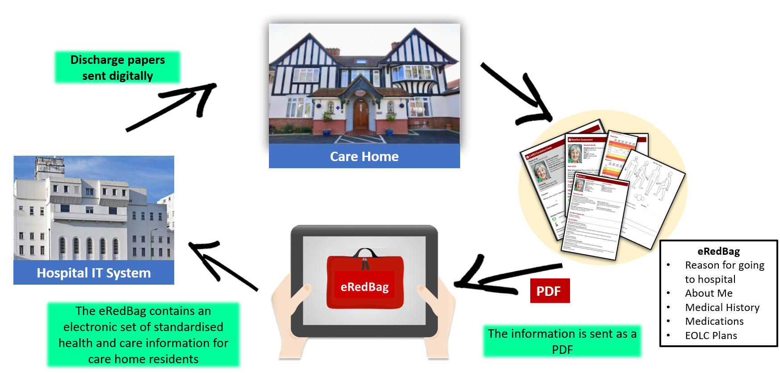

eRedBag implementation steps
There are three stages that need to be completed:
- The design stage
- The data governance stage
- The technical stage

The steps for design stage
The documentation set transferred from the Care Planning software should follow the eRedBag standard. Information within the eRedBag conforms to the Professional Records Standards Body (PRSB) standards for integrated health and social care. Standards relevant to the eRedBag are detailed in two national standards ‘About me’ and ’Urgent transfer referral form’. It is expected that some modification to the care providers software will be required to produce the necessary documentation/data set and to build a mechanism to send the information via the HSCN.

The steps for data governance stage
- Obtain an Organisation Data Service (ODS) code by registering on ODS website: Organisation Data Service forms - NHS Digital
- Register with the Information Commissioner’s Office (ICO): https://ico.org.uk/
- Once you have an ODS code you then register on the Data Security and Protection Toolkit (DSPT): https://www.dsptoolkit.nhs.uk/Account/Register
- Publish at Standards Met on DSPT
- Complete two Data Protection Impact Assessments (DPIA), one for the eRedBag and the other for the data that you are processing in your software solution
- Review your existing contracts against NHS contract requirements for data protection and ask clients to sign new contracts if required
- Check that the software user has published at Standards Met on DSPT by looking up the care home or the group provider on the DSPT search page (https://www.dsptoolkit.nhs.uk/OrganisationSearch), and has a Data Sharing Agreement in place with the relevant NHS services
The steps for technical stage
- Subscribe to the HSCN or be a member of CASPA. More information on setting up a connection with HSCN can be found here https://digital.nhs.uk/services/health-and-social-care-network.
- Ensure that all processes are running within UK datacentres for compliance
- Produce a PDF of the eRedBag for transmission to Hospital / LHCR systems
- Produce a HL7 FHIR bundle that contains the PDF and describes the person the eRedBag is about and the care home generating the eRedBag
- Send the Hl7 FHIR messages to the hospital/ CASPA/LHCR over the HSCN connection with retry logic if endpoint is not available
- Display back any messages to end users that may be generated i.e. invalid NHS number and Demographics combination.

Supporting your users / customers
Many care providers will be new to the concept of complying to data protection requirements to integrate with NHS services. You can help by providing them with your DPIA on the eRedBag, and with information they need to complete and publish Standards Met on the DSPT, such as where your data is held and wording for their privacy notices.

As a supplier, you must ensure that care providers using the eRedBag service comply with the minimum IG requirements: published at Standards Met on the DSPT and have a signed Data Sharing Agreement.

Suppliers, in their role as data processors, have a responsibility to only transfer data for care providers that comply with IG requirements and have a legal basis for sharing information (e.g., Care Act 2014, H&SC Act 2008, NHS Act 2006).

Going forward
Each year you will need to make sure that your organisation keeps up to date with changes to any of the standards. For example, certain items need to be reviewed annually on the DSPT Standards Met requirements and some requirements may change. You need to be aware of how your team expands over time and include the completion of IG/Data Protection training for all new recruits (NB: not just those in your technical team – it applies to all employees). In addition, as the technical standards evolve you will need to make sure time is allocated in your Product and Development lifecycle to adapt/comply to them.

For more information on the eRedBag, please contact:
SWLCareHomes.eRedBag@swlondon.nhs.uk

Acknowledgements

We would like to acknowledge and thank the following organisations for their ongoing commitment to this project:

