Guide for Community Staff

Guide to Implementing the eRedBag Pathway

Contents
1. Aim of this user guide 2
2. About the eRedBag 2
3. Benefits of the eRedBag 3
4. Ensuring your team can access the eRedBag 4
5. Promoting the eRedBag across community services team(s) 5
6. Monitoring use of the eRedBag 5

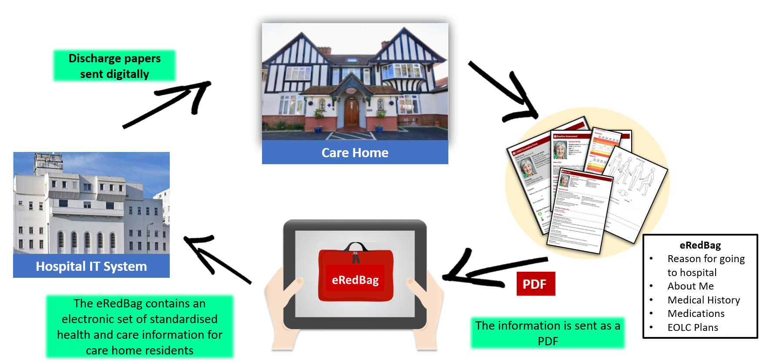

Date of publication: November 2022

Aim of this user guide
This User Guide provides guidance and advice to community services staff on how to access the eRedBag and how to promote it within their service. Learning has come from pilots and proof of concepts in South West London. The Guide is aimed at senior staff and leaders within community services.

About the eRedBag
When a care home resident needs to go to the Emergency Department (ED), a physical Red Bag is packed with the resident’s personal belongings as well as a paper copy of the resident’s health and social care information. It travels with the resident in the ambulance and moves with them throughout their time in ED and hospital stay.

The eRedBag is an electronic version of all the paper documents contained in the physical Red Bag. Care home residents’ physical Red Bags will still travel with the patient but there will also now be an eRedBag automatically accessible on the electronic patient record (EPR) within your hospital’s electronic system. On discharge, the care home’s staff will be able to view the discharge summary via the hospital’s electronic system however this is still in progress but likely to be live by early 2023.

Information within the eRedBag conforms to the Professional Records Standards Body (PRSB) standards. There were two, ‘About me’ and ’Urgent transfer referral form’ approved in 2020, which are relevant to the eRedBag:

- Transfer of information for urgent referral from care homes to hospital
- About Me

These standards describe the exact data items that must be transferred with a care home resident. In terms of groups of items, the eRedBag contains:

- Details of patient, preferred name to be called, care home (including secure email address), GP and next of kin
- CARES Escalation Form – symptoms, concerns and actions taken by care home
- Medical history, medication (MAR) and vital signs observations (if Nursing Home)
- Body map, including pressure sores
- CMC plan, Advanced Care Plan and DNACPR if any
- Reasonable adjustments and any Impairments
- About Me form, personal preferences, end of life wishes
- Safeguarding, legal information and risks
Additional support plans

Benefits of the eRedBag
Why do we need an eRedBag?
Previously:
“Paperwork can get misplaced, or it can be difficult to understand the handwriting” Nurse

Now:
Experience of a nurse accessing the eRedBag for an end of life patient:
“ . .. I was able to use that in my assessment to say right, actually I’m not going to take this patient any further because it contra-indicated her current wishes…. Having the information available to me on the computer meant I didn’t need to bring her in face to face and I didn’t need to organise a test - I would have ended up bringing her in, in an ambulance, putting her through something where she wouldn’t have been able to eat and drink for four hours just to have a scan that we already knew she didn’t want just by reading what’s in the eRedBag. So having it online was absolutely vital.” Clinical Nurse Specialist

The eRedBag has many benefits to individuals and organisations across the health and care pathway.

For community services, the key benefit of the eRedBag is easy access to information to support assessment and decision-making both in terms of preventing hospital admission from the emergency department (if providing a service there), supporting quicker and safer discharges once admitted and preventing readmissions once back in the care home.

Which services are run by the community teams will influence what benefits the eRedBag will bring to those teams (see Box 1).

Box 1: Services provided by Sutton Health and Care at Home Hospital Hub
Based at St Helier Hospital, our Hospital Hub Team (which consists of therapists, nurses, social workers and GP) works together and with hospital services to identify patients in the Emergency Department, Acute Medical Unit and on the wards, whose condition could be safely managed at home with the right support, reducing length of stay and unnecessary admissions.
https://www.suttonhealthandcare.nhs.uk/sutton-health-and-care-at-home

Benefits to the wider system are presented in more detail within the ‘Benefits and Opportunities of the eRedBag Pathway’ and ‘SQW Benefits of eRedBag’ documents found under the ‘Measuring the eRedBag Pathway’ section on the webpage. The Return on Investment (ROI) template (also found on the webpage) provides a tool for calculating feasible cost savings the eRedBag can achieve in relation to:

- Reductions in staff time spent filling in forms and repeating unnecessary investigations
- Reduction in emergency department (ED) admissions through reduced re-admissions
- Reduction in non-elective admissions through reduced re-admissions and more effective and efficient assessment in ED
- Reduced length of stay through support to discharge effectively and safely

Community Services working to prevent re-admission
The eRedBag contains the CARES (Concerns, Actions, Response and Escalation) Form detailing the reason for the emergency, including current symptoms and any actions taken by the care home. It also contains the resident’s medical history, their medication (MAR) and any vital signs observations taken as well as a body map (including pressure sores) and any CMC plan, Advanced Care Plan and DNACPR.

This information can help community teams assess the resident and aid decision making for support required to avoid re-admission.

Community Services working in the Emergency Department (ED) or Acute Medical Unit (AMU)
For community teams working in ED or AMU to prevent admission from there into the hospital, the eRedBag supports better decision making by including information on previous acute episodes, level of functioning, cognition, dementia status, mobility and continence. It also contains the About Me form, listing personal preferences and end of life wishes. The eRedBag appears to reduce the number of people admitted to hospital from ED (Non-Elective Admissions) due to more effective and efficient assessment in ED.

Community Services working on Discharge
Phase 1 of the work in SW London suggested it reduces overall length of stay (LOS) through more timely care and quicker and safer discharges, thereby increasing capacity and reducing the risks of Hospital Acquired Infections and deconditioning for patients from care homes. Average length of stay for care home residents with an eRedBag reduced by an average of 1.6 days per patient. To help speed up discharge there is information on safeguarding, legal information, risks and additional support plans.
“Getting hold of and finding red bag info can be hard, so being able to find and access typed info electronically is very helpful, particularly as this helps with understanding functionality… ‘Are they usually confused, what do they usually eat and drink?’ … All these things which are important for us to consider holistically.” Doctor

Ensuring your team can access the eRedBag
To ensure your community team knows about the eRedBag and can access the information, there are a number of actions to be taken. To deliver the actions and realise the benefits, we suggest that a small Task and Finish group containing a manager and two or three colleagues is set-up to work with an area/Integrated Care System leader.

Accessing the eRedBag
The Task and Finish group should liaise with the acute trust’s IT department and identify the hospital IT lead for the eRedBag. The IT lead can confirm how the community team is able to access the eRedBag on the shared care record, Health Information Exchange (HIE) or hospital EPR system.

Each NHS acute trust implementing the eRedBag will have an eRedBag corporate lead at a senior executive level, as well as usually a head of nursing, who can provide further support on accessing the eRedBag. The Task and Finish group should ensure all community services staff are able to access the eRedBag.
Watch and promote the eRedBag Video (1 min :53 seconds long) -
it explains how the eRedBag will help clinicians with patient care.

Promoting the eRedBag across community services team(s)
As with all new initiatives and changes to normal working practices, community services staff will need good communication and information about the eRedBag to be able to use it effectively.

Some additional recommendations for the Task and Finish Group to consider are:

- creating a Champion for the eRedBag in the service and within each community team
- using physical tags as a reminder – magnets, stickers, posters, pens – they all help spread the message – “The eRedBag is now live on EPR”
- promoting it via e-communication - newsletters, WhatsApp groups, email signatures, screensavers and set-up an intranet page.
- riding on the success of previous internal campaigns – your communications and transformation teams will know what works best for your service. Use their expertise to guide you.
- using techniques such as ward walk-rounds, study days and team meetings and include within induction packs
- setting up a dummy care home resident on your service’s EPR and attaching a dummy eRedBag on it so staff can access it and review it before going live
- generating user stories of clinicians who have accessed the eRedBag using the interview template available on the webpage

Monitoring use of the eRedBag
It is advisable to monitor the use of the eRedBag in the community team. The trust’s IT lead may be able to help contact staff accessing the eRedBag. This can be matched with records of care home resident referrals to the community service to help generate users’ experiences of accessing the eRedBag.

Where the eRedBag is not being accessed, the Task and Finish group can raise this in team meetings to discover if there is a problem with access, or if more promotion is needed.

Further eRedBag resources are available on the website.

For more information on the eRedBag contact SWLCareHomes.eRedBag@swlondon.nhs.uk

Acknowledgements

We would like to acknowledge and thank the following organisations for their ongoing commitment to this project:

