What is the eRedBag Pathway?

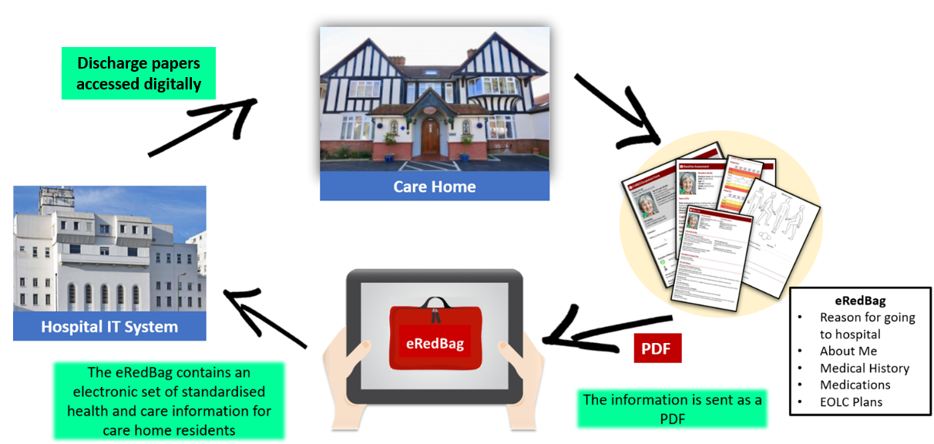
The eRedBag Pathway is the digital transfer of the electronic versions of the paper documents included in the Hospital Transfer Pathway, more commonly known as ‘Sutton’s Red Bag initiative’. It has been developed to further improve the information sharing and communication between care homes, ambulance services, hospitals and community teams that the Red Bag documents delivered. By sending the information in digital format, the eRedBag is available to staff providing care at the touch of a button. The eDischarge Summaries are still being worked on with completion by early 2023.

The eRedBag contains all the original information and more. Since the document is electronic, the eRedBag information is clearly laid out, in colour, can include colour photos and is type written – no longer do people have to try and read people’s handwriting. The pdf supports easy searching for information required and information is readily accessible. The actual information in the eRedBag also meets the Professional Records Standards Body's national standards.

Multiple benefits of the eRedBag Pathway have been evidenced. System level cost savings have been demonstrated resulting from reductions in avoidable transfers to hospital and in non-emergency admissions to hospital, from reduced length of stay in hospital and greater staff efficiencies. In addition, there are better patient/resident experiences; there is a reduced need to replicate unnecessary tests; communication is better and staff satisfaction is improved.

The eRedBag is available to be rolled out across England from 2021 through a package of guides and tools to support implementation. For more information, please email SWLCareHomes.eRedBag@swlondon.nhs.uk.

