Date: 27 May 2021

|  |
| --- |
| Product Information Sheet: eRedBag ‘paper-based’ solution |

## Why (problem aiming to solve)

In 2019 the eRedBag was born; enabling care homes using Mobile Care Monitoring (MCM) by Person Centred Software to transfer a digital version of the Red Bag standard documentation directly to the hospital.

However, not all homes have taken the leap into the digital world for care planning and/or point of care recording of care provided.

Person Centred Software has developed a digital solution that enables homes using paper records to be able to send a digital copy of the documentation.

In 2020 as the COVID-19 pandemic hit the world; the need for digital and remote access to records was highlighted. Barriers to data sharing were lowed and interorability between health and social care became essential to supporting those receiving care and those providing care in care home settings. Person Centred Software in collaboration with the NHS delivered the ability to access GP records by embedding the NHS “GP Connect” solution directly into the MCM.

## What (feature overview)

The eRedBag solution for homes that are paper-based, or that are non-MCM users, is a secure portal designed to run on an iPad to digitally transfer information from the care home to the hospital.

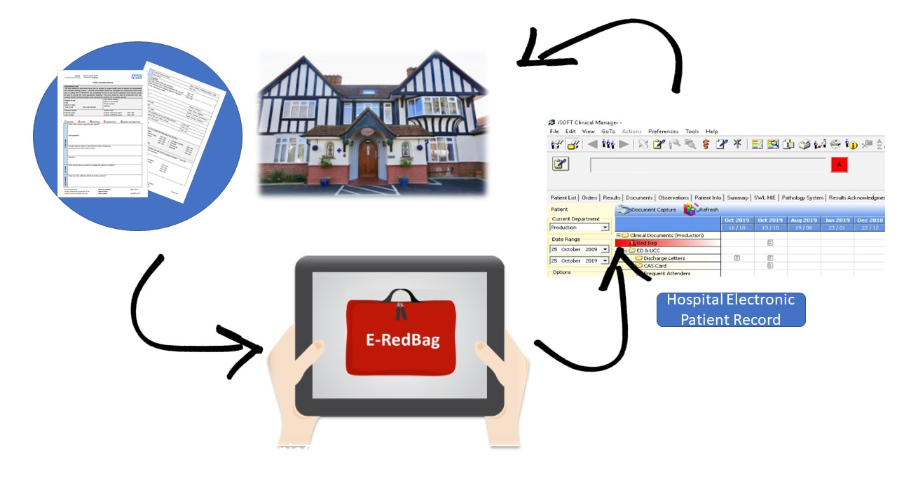

Each organisation participating will be set up on the portal – with the location for each care home set up to hold basic resident details and their red bag documentation – ready to be sent when they are transferring to hospital.

The solution is designed to run on an iPad using ios 11 running Mobile Care Monitoring. Mobile Care Monitoring is a hosted service by Person Centred Software.

The solution will require an iPad (not provided) and an iBeacon (provided) and a small system fee of £5 (inclusive of VAT) per home per month. Support for set-up will be provided by South West London Health and Care Partnership.

Information held on the eRedBag ‘paper-based’ solution includes:

* Resident names, photos and core demographics
* Images of paperwork included in the current red bag:
  + CARES escalation form
  + Baseline assessment
  + Who I am / This is me (or equivalent profile)
  + DNACPR
  + MAR sheets
  + Advance Care Plan
  + Other supplementary images as required (e.g. belongings or useful guidance to support individuals)
* iBeacon – control login to access information based on being in close proximity to a secure location (the same level of security as paper)

## The eRedBag Solution

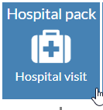

The MCM eRedBag solution enables providers to preload information about residents (photos and demographic information). Photo images of some documents can also be preloaded to the hospital pack, such as the baseline assessment, DNACPR, the This is Me profile and other images of important information that may improve the quality of care they receive when moving care settings, e.g. how the residents hearing aid should be fitted.

The eRedBag means that in the event of the need to transfer from the care home setting to the hospital, information is ready to go and can be sent digitally when needed. At the time of escalation; the care team grab the iPad held in the designated secure location at the home. An iBeacon will be installed there and will be used to grant access to the system.

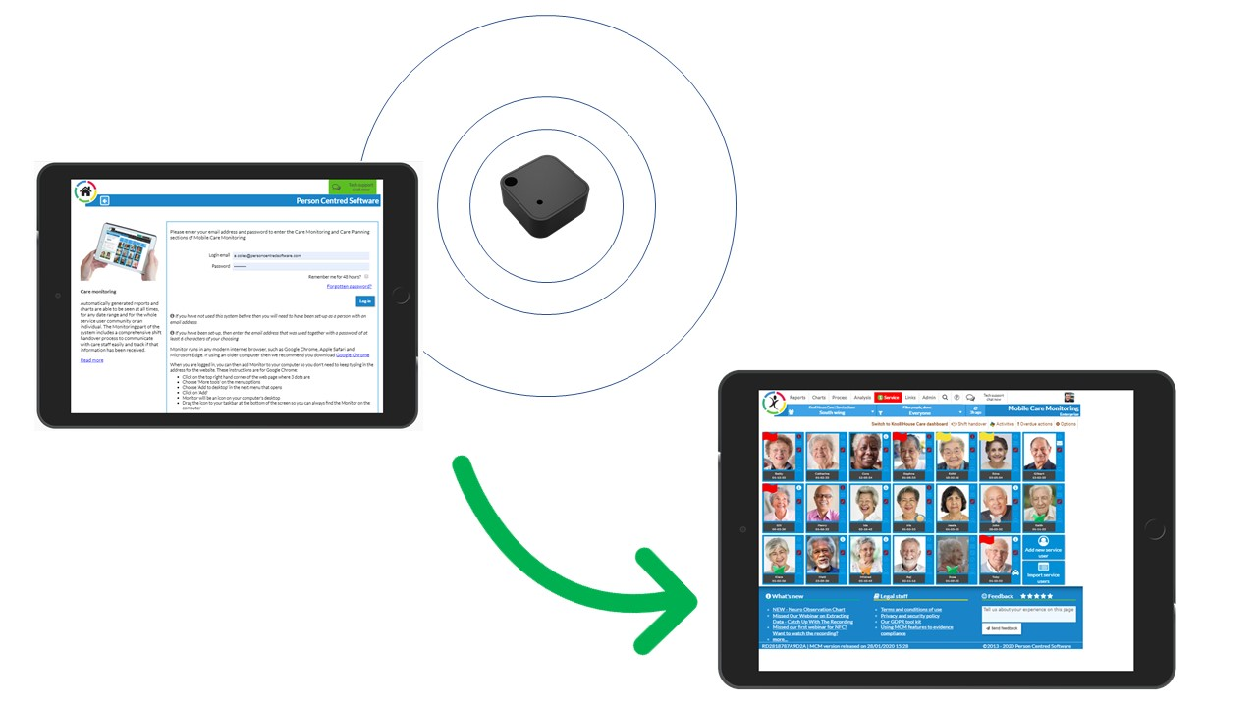

Once in the resident records – the hospital pack button is pressed and the carer team can take photo images of the necessary red bag documentation, such as the “CARES Escalation” form, MAR sheets and even images of belonging that have been put into the bag.

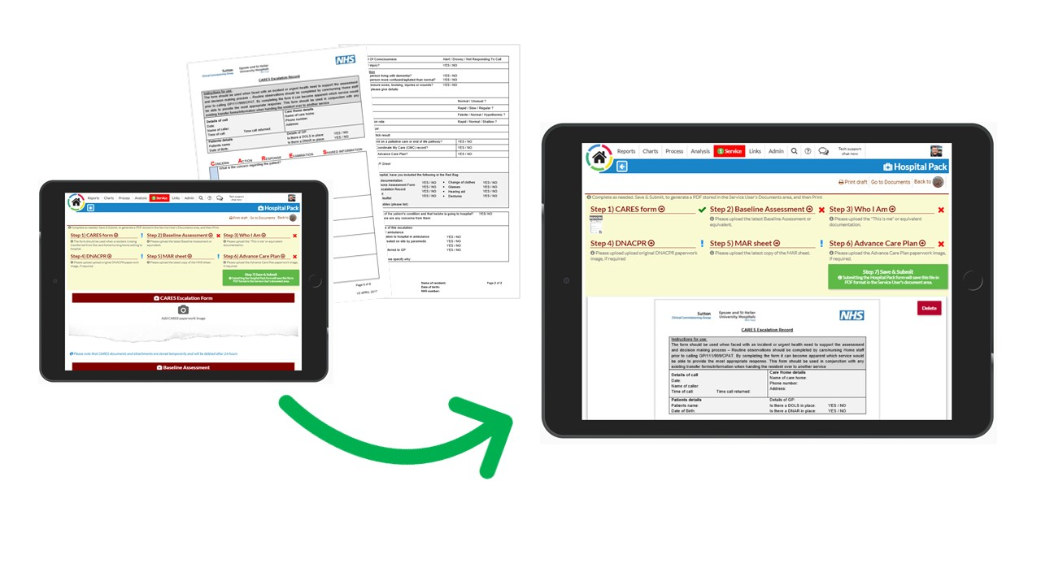

## GP Connect

Mobile Care Monitoring is able to display information held on GP records. Giving care homes access to summary information held on NHS records. GP Connect is an NHS managed services that pulls information from various GP surgeries (circa 97% of surgeries in England).

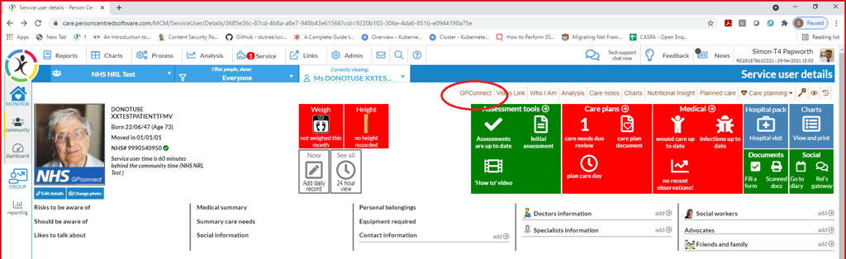

The NHS engaged with Person Centred Software to enable Registered Clinical staff in homes to access the service through MCM. GP connect includes

* **Encounters** – e.g. hospital visits
* **Active problems and issues** – e.g. diagnosis
* **Allergies and adverse reactions**
* **Acute and repeat medication**
* **Referrals**
* **Observations** – e.g. pulse, oxygen saturation
* **Immunisations**

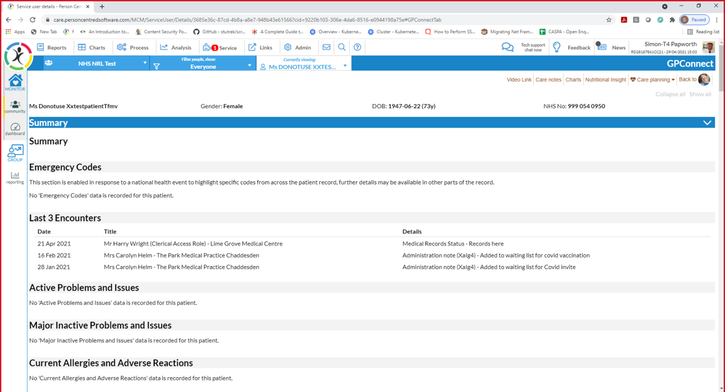

The solution will require the same device used for the eRedBag and a system fee of £45 (inclusive of VAT) per home per month for a single monitor license.

## Key Customer Benefits

**eRedBag:**

* Improves the transfer to hospital process
* Information available to all the teams supporting a patient at the hospital
* Enables better care for the resident in hospital in line with their wishes, needs and preferences
* Easy to use and does not require onerous administration by care home staff
* Information held and transferred securely
* Information can be prepared in advance, reducing the worry of collating information at the time of emergency
* Secure access to information

**GP Connect:**

* Easy access to information held on GP records
* Accurate medical history instantly
* Answers your queries without having to contact the GP surgery

## Next Steps

For a demo and more information about this eRedBag solution, please get in touch with Andrew Coles, at Person Centred Software via [A.Coles@personcentredsoftware.com](mailto:A.Coles@personcentredsoftware.com) or 07734 176252

For more information about the eRedBag project, please contact SWLCareHomes.eRedBag@swlondon.nhs.uk

Looking forward to hearing from you