Guidance for Ambulance Staff on accessing the eRedBag
For more information on the eRedBag, please look at the document called eRedBag Pathway on a Page. You can find a dummy eRedBag, as well as other information about the eRedBag Pathway, on the webpage. The eRedBag can help make better clinical decisions. It contains both health and social care information captured in the resident’s care home and makes it available to the ambulance crew. Accessing the information will help ensure people’s wishes are taken into account and will improve both communication and quality of care provided, and in particular, it will support triage decisions.

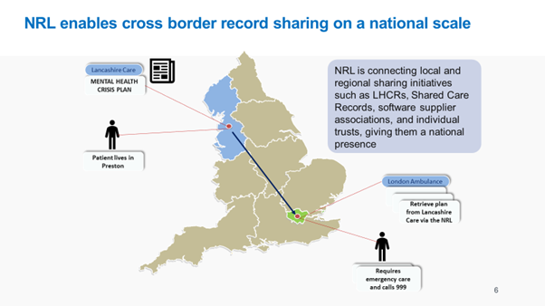

Ambulance Staff can now locate the eRedBag through the National Record Locator (NRL). There is more information here: https://digital.nhs.uk/services/national-record-locator
The NRL enables an authorised clinician, care worker and/or administrator, in any health or care setting, to access a patient’s information to support that patient’s direct care.
This is achieved by way of a national index of pointers that are essentially bookmarks that can tell authorised clinicians, care workers and/or administrators what shared records may exist for a patient and where they exist. Pointers are created by the organisations that own the records. These pointers can then be viewed by other organisations in their own electronic clinical/care systems and/or SCRa.
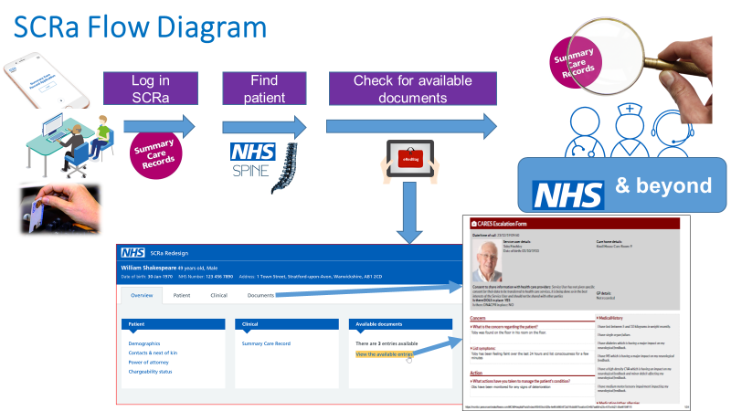

Further Information
Regional Ambulance Trusts wanting to access the eRedBag through the NRL can email nrlnems.ls@nhs.net and ask what is available in their area.

For more information on the eRedBag Pathway, please contact SWLCareHomes.eRedBag@swlondon.nhs.uk

Date of publication: July 2021

