The Short Guide to the eRedBag Pathway

The eRedBag Pathway helps improve the experiences and quality of care of residents moving from their care homes to hospital in an emergency, and then back to their care homes. The eRedBag provides healthcare staff with up to date information about care home residents, quickly and easily, to enable them to deliver the best possible care.

Contents
1. What is the eRedBag Pathway? 2
2. What information does the eRedBag contain? 3
3. How is the information transferred electronically? 3
4. What are the benefits of the eRedBag? 4
5. What stage is the eRedBag project at? 4
6. What are the challenges to implementing the eRedBag? 4
7. Where to find more information? 4

Date of publication: April 2021

What is the eRedBag Pathway?
Put simply, the eRedBag Pathway is the electronic version of the paper documents included in the Hospital Transfer Pathway, more commonly known as ‘Sutton’s Red Bag initiative’. The Red Bag initiative was initiated in Sutton, South West London, in 2015, as part of the Enhanced Health in Care Homes Vanguard. The contents of the Red Bag are put together for when a resident is transferring from a care home into hospital either urgently or in an emergency. The red bag contains key paperwork, medication and personal items like glasses, dentures and hearing aids, and is handed to ambulance crews by care staff. It then travels with the resident to hospital where it is handed to staff in the emergency department.

The Red Bag project aimed to improve resident’s experiences and outcomes through transferring their important information, belongings and clothes to return home in, when they required urgent care in hospital. Users of the Red Bag report that it results in better quality, joined-up care, delivered in a timely manner and significant cost saving were also reported. The initiative is an example of integrated working across health and social care.

Following the success of the Red Bag scheme in Sutton, and the subsequent roll out across over four-fifths of the country, it was recognised that the project could be made more effective if the information in the paperwork was shared electronically. Following six months of technical development and information governance hurdles, the eRedBag was a success. The first eRedBag transferred to hospital in February 2019. In South West London this innovation is known as the eRedBag – though for coding purposes it is referred to as the ‘Care Home Emergency Pack’ on our SWL Health Information Exchange. The physical bag remains a central part of the initiative but there is enhanced capability, from the electronically transferred information, for more joined up, responsive care.

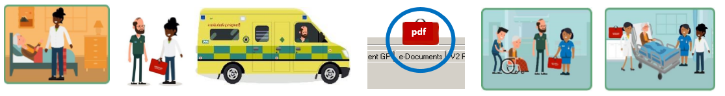
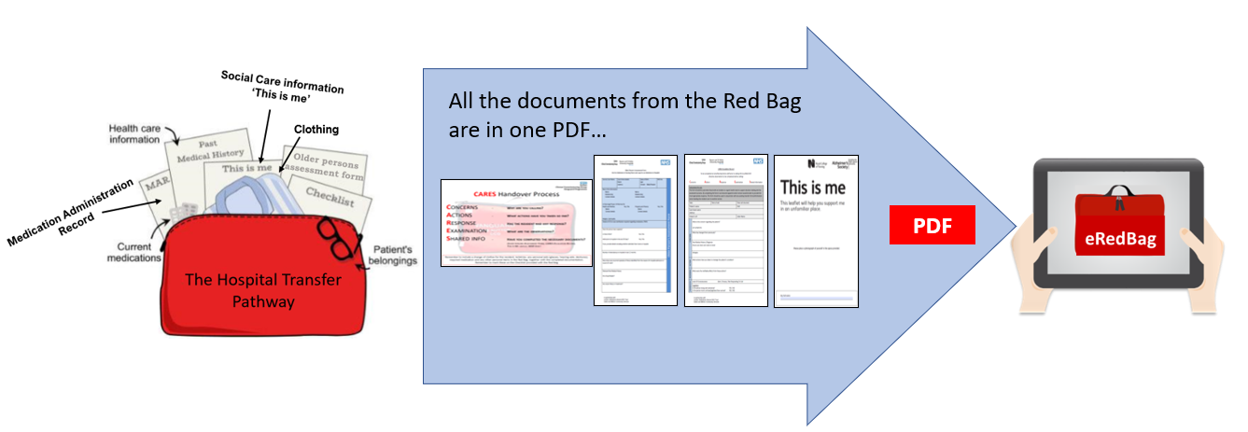

What information does the eRedBag contain?
The eRedBag is a collection of data items, currently brought together into a PDF document, which includes:
- Details of patient, care home (including secure email address), GP and next of kin, preferred name, NHS number
- CARES Escalation Form – symptoms, concerns and actions taken by care home
- Medical history, medication and vital signs observations
- Body map, including pressure sores, and mobility status
- End of life care plan and wishes
- Reasonable adjustments and any impairments
- About Me form - personal preferences and information about themselves
- Safeguarding, legal information and risks
- Additional support plans

There is now a standard list of data items. In October 2020, the Professional Records Standard Body (PRSB) published five national standards for sharing information between health and social care. The new standards outline key information, such as how someone’s needs might change after being in hospital and how this needs to be recorded. Two of the new standards relate to information held within the eRedBag. These standards are:

- About Me – the information that people want to share about themselves
- Urgent referral from care home to hospital – information required for the care and support of a person when they are admitted to hospital from a care home in an emergency

How is the information transferred electronically?
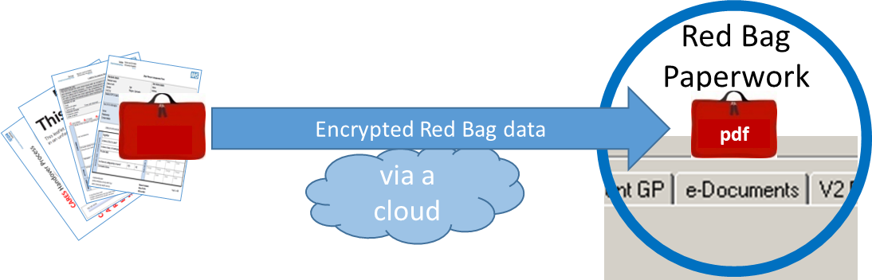

The eRedBag is transferred electronically from the care home via encrypted, cloud-based software and a secure network connection, to the NHS. In order for the ambulance crew to view the eRedBag on the way to hospital, it is transferred via the National Record Locator and Summary Care Record application. At the same time, it is transferred to the local shared care record, called Connecting your Care, in order for staff at all four hospitals in South West London to view the information, as well as the community teams and general practice.

What are the benefits of the eRedBag?
The eRedBag has many benefits to individuals and organisations across the health and care pathway. They are both non-cashing releasing financial benefits and quality benefits; both have been witnessed at all system levels. The full benefits are detailed in the document: ‘eRedBag Pathway Benefits Paper’ in the Mobilisation Pack.

In summary, the communication across health and social organisations of reliable, trusted, up-to-date, consistent quality information about patients/residents that is readily available leads to…
…short term benefits:
- Improved experiences, quality of care and safe-guarding for care home residents
- Improved assurance for family members, friends and carers
- More time available for staff to spend caring for people
- Improved job satisfaction for staff
- Quicker and safer discharges
- Reduced risk of data breaches
…system benefits:
- Care staff feel more connected to the broader health system
- Cost savings through less people going to hospital, fewer unnecessary tests and interventions whilst in hospital, and less time in hospital
- Improved compliance and understanding of data protection, and data and cyber security.

The financial benefits are:
- Reduced ED attendances (non-cashable)
- Reduced admissions (non-cashable)
- Reduced length of stay (non-cashable)
- Reduced readmissions (non-cashable)
- Reduced ambulance conveyances (non-cashable)
- Increased hospital staff productivity (non-cashable)
- Increased care staff productivity (non-cashable)

What stage is the eRedBag project at?
At the time of producing this document (March 2021) the project sponsored by NHS Digital has been completed in South West London. From December 2019 to January 2021, work focussed on delivering the technical capability, supporting homes to meet information governance requirements and engaging with users of the eRedBag. Although Covid has inevitably caused delays to the project timetable, more care homes across SWL are currently being supported to help access the scheme, and more engagement is happening with hospital and ambulance staff to understand their experiences. From April 2021, the eRedBag will move from a project to be part of SWL CCG’s programme of work.

What are the challenges to implementing the eRedBag?
Lessons have been learnt during implementation that relate to:
- The importance of timely and extensive stakeholder engagement across the whole health and care network
- The value of engaging senior clinicians in the hospitals who can act as advocates and mentors to encourage access to the eRedBag
- Allowing plenty of time to support care homes to reach minimum required standards for information governance and data protection
- Targeting the care homes that already use software to deliver planned care as they are often in a position to move forward at pace
- Engaging care homes early with the concept and keeping up momentum, providing support to connect remotely for staff training
- Working with software providers to engage with homes already using their products.

Where to find more information?
The eRedBag is available to be rolled out across England in 2021 through a package of guides and tools to support local implementation available at https://healthinnovationnetwork.com/resources/implementing-the-eredbag-pathway/

For more information, please email SWLCareHomes.eRedBag@swlondon.nhs.uk

Acknowledgments

We would like to acknowledge and thank the following organisations for their ongoing commitment to this project:

