Engage Consult; Digital Self-Referral for MSK
https://bexleymsk.engage.gp/
September 2021
Report Author: Heather Ritchie, Beverley Cantellow
Clinical Lead: Heather Ritchie
1.0 Executive Summary

NHS Delivery of Musculoskeletal (MSK) Services poses significant challenges with an ageing population and growing complexity of pathology placing increasing demand on existing community services. In addition, the burden on primary care is great with around 30% of all GP consultations relating to MSK pathology (NHS Long Term Plan, 2019). Considering this, Bexley MSK Service has launched a digital strategy to better manage this demand; by improving access to self-referral and self-management strategies for MSK conditions with innovative use of Information Technology in the borough of Bexley.

The digital initiative has been supported by the Health Innovation Network’s (HINs) digital innovations grant with £10,000 awarded to implement and develop the technology in an NHS MSK Outpatients setting.

Key Successes – summarised
- Development of condition specific online resources
- 2946 number of patients utilised digital self-referral
- 796 number of patients utilised online resources without completing a self-referral

Key concerns – summarised
- Second milestone not reached; patients not offered individualised care at the point of contact
- Engage Touch not implemented as planned

2.0 Introduction

Bexley MSK Service is a large Multidisciplinary Team of Physiotherapists, Podiatrists, Hand Therapists and Psychologists offering rehabilitative MSK care to residents in the borough of Bexley. The service ethos is in keeping with GIRFT Project (Getting it Right First time, 2016) and aims to offer a single point of access to patients with MSK conditions, delivering the right care at the right time. The majority (90%) of patients are seen in a community hospital setting by the therapy team and are managed conservatively where possible. The MSK service aims to reduce unnecessary appointments and needless interventions in Secondary Care though seamless pathways do exist where there is a clinical need such as a legitimate surgical target.
The service was originally set up in 2014 and since that time there has been a growing demand for access to the therapies. Bexley MSK service has seen a 17% increase in referral rates in a 5-year period and it is estimated that the rates of referrals will continue to increase year on year, in keeping with national trends. The increase in referral rates is considered in this instance to be a positive reflection on the reduction of referrals into secondary care which is cost-effective and in keeping with NICE guidance for the management of MSK conditions. This does however have implications on how the service can be delivered and a culture of continued service innovation is needed to manage the increased demand.
Patient activation describes the knowledge, skills, and confidence a person has in managing their own health and care. Evidence shows that when people are supported to become more responsible for their own health, they benefit from better health outcomes, improved experiences of care and fewer unplanned care admissions. Patient activation is of particular importance to the 15 million people living with long-term conditions (LTCs) who rely, more than most, on NHS services. Innovative ways to improve self-management utilising Information Technology will play a key part in improving self-efficacy and give the residents of Bexley the confidence to manage their conditions at home when clinically it is considered safe to do so (The Kings Fund, 2014).

3.0 Aim/Purpose

To improve access to self-management strategies for Musculoskeletal conditions with innovative use of Information Technology in the borough of Bexley. To reduce the burden of MSK pathology on GPs by introducing digital self-referral in the Bexley locality.

- Objectives

Phase One Objectives:
- Employ the services of Engage Health to create a top quality, secure, entirely editable Bexley MSK self-referral portal with self-help guides and positive health messages.
- List helpful social prescribing tools such as weight-loss resources and free exercise activities which can be accessed in the borough.
- Utilise Engage Consult as an online consultation and discussion (e-consultation) application enabling patients to self-refer for musculoskeletal conditions using an efficient online health and medical history-taking service (including STaRT Back and Oxford joint scales), coupled with an integrated secure messaging service.
Phase Two Objectives
- Offer users of digital self-referral the opportunity to self-select the type of help and support they feel they would like to include self-management advice and education, request to be seen in clinic for a face-to-face appointment, attend an education session, or speak to a clinician directly via telephone triage.
- Implementation of self-check in screen (Engage Touch) in the MSK waiting area

5.0 Standards/Guidelines

Musculoskeletal (MSK) conditions account for 30 per cent of GP consultations in England. Low back and neck pain are the greatest cause of years lost to disability in the UK, with chronic joint pain or osteoarthritis affecting more than 8.75 million people in the UK. As such, direct access to NHS MSK Services is a key component of the NHS Long Term Plan with recommendations from NHS England for local systems to increase access to therapy-lead services to reduce the pressures on GP workloads and the costs associated with direct referral into secondary care. (NHS Long Term Plan, 2019)

6.0 Methodology

A project was developed and agreed between Bexley MSK (BMSK) and Engage Consult including timeframes for completion and task leads (Appendix 1).
Project initiation, installation and training led by colleagues at Engage Consult over a 1-week period. This included adding links directing services users to readily available and generalised self-management resources including Versus Arthritis (www.versusarthritis.org), NHS Fitness studio (www.nhs.uk/conditions/nhs-fitness-studio), Sport England Get Active (www.sportengland.org/jointhemovement) and NHS Better Health (www.nhs.uk/better-health). Figure 1.
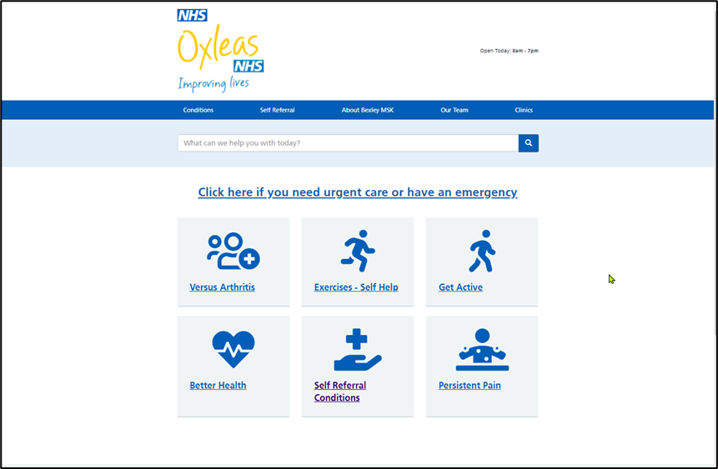
Figure 1: Bexley MSK Landing page for Engage Consult including general Self-Management resources relating to Version 1 of the online portal.
A pilot project consisting of 2 GP practices was initiated by the MSK Service Manager over a 5-week period. Further GP Engagement was initiated via emails and discussion at locality meetings; the self-referral portal was further implemented onto 21 of the 22 GP practice websites with support from Engage Consult technical team who liaised directly with website providers from each GP practice. It took a total of 21 weeks to roll out self-referral access across the entire borough. Only 1 GP practice failed to respond to the project request however registered patients of the practice are still able to self-refer by accessing the Oxleas’ website. Figure 2.
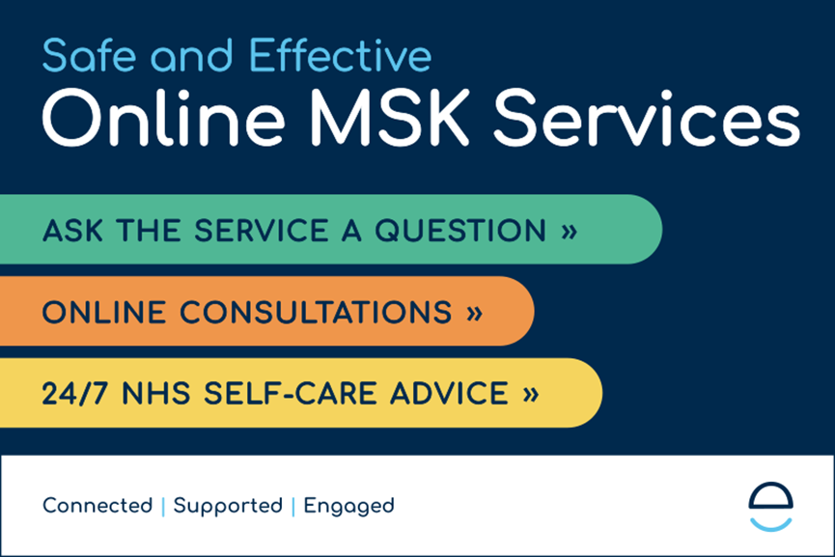
Figure 2: Patients are able to self-refer via their GP website or the Oxleas Bexley MSK Site by clicking on the Engage Consult Banner which takes them through to the self-management portal
Figure 1: Bexley MSK Project Plan showing each developmental stage
A mid-stage review was conducted following qualitative feedback from the therapists within the MSK team. Further qualitative review of the Engage Consult system and MSK internal processes concluded that MSK-specific questionnaires were needed to better manage this type of referral pathway, and a further developmental stage was added. MSK questionnaire content was created by the clinical leads for each speciality area including Extended Scope Physiotherapists specialising in the Spine, Neck, Upper Limb (shoulder, elbow), Lower Limb (Hip, Knee), Extended Scope Podiatrists (foot, ankle), and Occupational Therapist Hand Therapists (hand, wrist). Further development of questionnaires – including coding, troubleshooting, and reviewing for errors - occurred with support from Engage Consult Technical team. It took a total of 24 weeks to create questionnaires which were ready to go-live on the Engage Consult portal. The system makes it clear to service users that the service is not intended for emergency pathology and requests that patients confirm they understand they are accessing a non-emergency service (Figure 3). Additionally, the questionnaires including safety questionnaires around sinister and worrying pathology, such as Cauda Equina, those who answer positively are given a prompt to seek urgent medical advice and clinicians are shown the warning upon receipt of the self-referral (Figure 4)

Figure 3: The Engage Consult system shows service users a general medical warning message prior to starting the self-referral process.
Figure 4: Questions for sinister and urgent pathology include conditions such as Cauda Equina Screening, systemic feelings of unwell and unintentional weight loss.
Project preparation included writing and developing a range of condition-specific patient information leaflets and educational videos. The resources were created during group-work lead by therapists working in Bexley MSK Service over an 18-week period; a total of 98 self-management resources were created to be used at a later stage in the project. A new online portal was created using the existing generalised self-management information, educational videos, condition-specific patient information leaflets and the MSK-specific Engage Consult questionnaires. The self-referral portal is available to view at https://bexleymsk.engage.gp. Figures 4, 5.
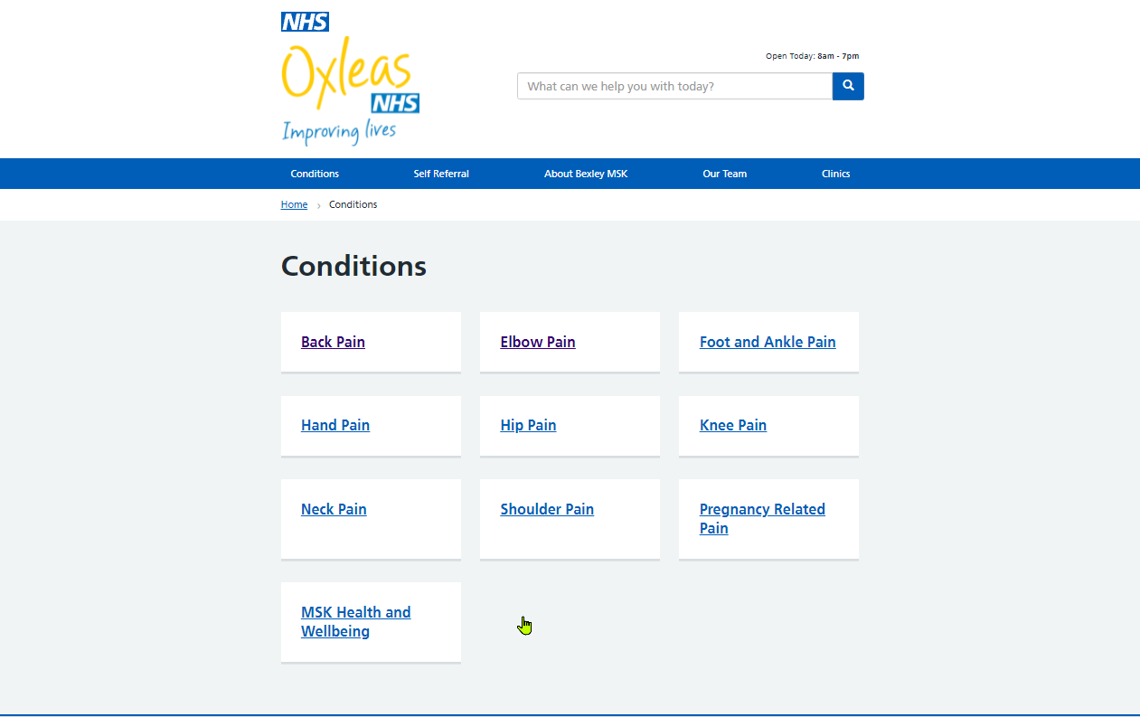
Figure 4: Condition-specific resource page containing patient information leaflets for a wide range of MSK pathology, including first-line interventions and rehabilitation plans
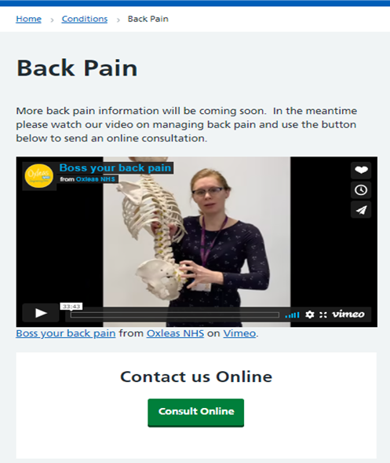

Figure 5: Service-users are encouraged to watch the Bexley MSK Back Pain Education Video prior to self-referring into the service. The video includes helpful messages on exercise as medicine, the sensitised system, back pain myths, as well as signs and symptoms of more sinister pathology.

7.0 Sample

Service user data was taken from September 2020 – August 2021.

7.0 Caveat

In response to the COVID-19 Pandemic and in line with the clinical prioritisation document, issued on Friday 20th March 2020 Bexley MSK was required to step-down all low and medium aspects of the service with immediate effect from months March-August 2020. The impact of this was that self-referral was not launched until September 2020 when a recovery plan was put in place to reinstate services; the project was therefore delayed against all milestones due to the first wave of the COVID-19 Pandemic and was further impacted by the second wave during which all operational resources were diverted towards further redeployment of staff and non-essential service-development initiatives were placed on hold.

8.0 Results

The overall number of referrals received into the MSK service were collated from RIO software. Bexley MSK referral rates are typically fluctuant and range between 1800-2200 (average 2000) per month however due to the COVID-19 pandemic the number of individuals referred into the service has been more variable. Lower referral numbers during the First Wave of the Pandemic (April 2020) and the Second Wave are reflected in Figure 6. The overall number of referrals into the service has not increased following the implementation of self-referral.

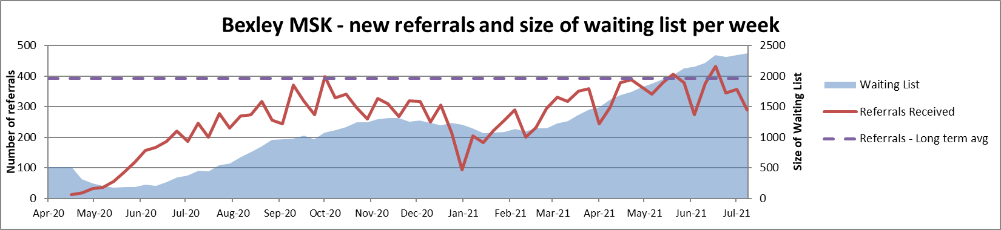
Figure 6: Bexley MSK Referral figures; data for all referrals received into the Bexley MSK Service did not increase as a result of launching self-referral in October 2020.

Self-referral data was collated from the Engage Consult software to extract the number self-referrals received vs. referrals from GP and Consultant. The number of service users who chose to utilise digital self-referral grew by from 19 to 535 per month between the months of September and July 2021 which is a percentage increase of 2816% over a ten-month period. The total number of referrals received via self-referral was 2946 over the ten-month period. The number of service users who utilised the self-management resources but did not complete a self-referral grew from 2 to 154 per month over the same period which is a percentage increase of 7600% over a ten-month period. The total number of service-users that utilised self-management resources but did not go on to complete a self-referral was 796 over the ten-month period. The data for utilisation of the self-management resources reflects Version 1 of the online platform, which included signposting to; Versus Arthritis, NHS Fitness studio, Sport England Get Active and NHS Better Health and does not contain data on access to the condition-specific self-management resources which were not launched until September 2021. Figure 7.

Figure 7: Growth of Engage Consult system use over a ten-month period; service users who self-referred for their MSK pathology and those who have utilised self-help resources have increased since the system was implemented.

The breakdown of referral numbers by body-art is shown in Figure 8. Data is taken from the body part which was self-identified by the patient and does not include accurate diagnosis or the possibility of referred symptoms from another body part, i.e., radicular arm pain. Most patients using the self-referral portal presented with back pain (21%), knee pain (14%) and shoulder pain (11%) and this is in keeping World Health Organisation (WHO) data on the burden of MSK pathology. Neck pain prevalence was low compared to WHO data on the prevalence of MSK pathology (WHO, 2021) and anecdotal service-level data on the number of service users who present with neck pain. No comparative data exists for the breakdown of affected body part received via other referral routes (GP E-referrals or consultant paper referrals) due to limitations that exist within the other systems in place.

Patient experience of using the self-referral portal was generally positive with 63% of service users reporting that they would recommend Engage Consult online services, 27% reporting that they were not sure if they would recommend, and 10% reporting that they would not recommend.
Figure 8: Breakdown of the total number of self-referrals received by body part; a total of 2946 service users accessed Bexley MSK Service via this route over a ten-month period

9.0 Observations

A total of 2946 patients have self-referred to Bexley MSK service over a 10-month period and the number of monthly users continues to grow each month. Access to digital self-referral in the borough appears to have improved patient access to MSK services in the borough without increasing demands on the MSK service, with no increase in the overall number of referrals received. It is anticipated that up to 2946 GP appointments may have been saved over a 10-month period in support of the NHS Long Term plan, however no data exists to quantitatively assess the impact on GP practices at this time.

A total of 796 patients utilised online self-management resources without subsequently completing a self-referral for MSK services over a 10-month period. The development of online self-management resources is considered successful, and data reviewed over the 10-month period suggests that improving access to self-management resources may reduce the demand on MSK Services over time. Availability of self-management resources was limited to generalised MSK management resources and did not included condition-specific resources or resources relating to complex or persistent pain. Improving access to self-management resources may further reduce the demand on MSK services and a continued review of how well these are utilised should occur over the next 12 months as the newly developed condition-specific patient information leaflets and educational videos are made available.

Engage consult was selected as a suitable online consult platform based on data which demonstrated the system was being successfully used across multiple GP practices with good effect. The system was deemed safe and effective for patients presenting with musculoskeletal pathology in primary care and so the decision was made that the existing systems would be transferable to a musculoskeletal service. Following the launch of the self-referral portal in Bexley MSK some difficulties were encountered with how readily the system translated into an MSK Outpatients setting; questionnaires which existed for medical practitioners treating musculoskeletal pathology consisted of additional medical screening questions which would not routinely be included in a physiotherapy-lead service, and as such it was agreed that to be effective within an MSK outpatients setting the content of the online consultations needed to be MSK-specific. Significant further clinical discussion occurred at this stage and further scales were added, including the Quick-DASH, Manchester-Oxford Foot Questionnaire and the Patient-Specific Functional Scale.

It should be noted that the system was trialled in full knowledge that it would require further work if the initial trial with the non-modified GP version showed promise. The GP version allows patients to type in their problems and it was recognised that a limited menu of conditions is required for most effective use in the MSK self-referral setting.

Bexley MSK was well supported by Engage consult to develop a new set of online consultation questionnaires to ensure that the information gathered from our service users was specific and relevant to their rehabilitative needs. The first of these – a back pain questionnaire - was successfully implemented in September 2021 and has improved the quality of the information being received. Questionnaires for the other body parts to including neck, upper limb, hand/wrist, hip, knee and foot/ankle are due to go Live on the system in October 2021. Development of the questionnaires generated a significant increase in project work and contributed to the MSK service being unable to reach it’s second milestone of providing individualised patient care at the point of self-referral. However, it is anticipated that by improving the quality of the information being received into the service we will be able to work towards our this goal and continued development of the self-referral project will occur over the following 12-month period.

10. Recommendations

Engage consult appears an effective means of improving patient activation and access to self-management strategies for patients presenting with painful musculoskeletal conditions. Digital self-referral via an electronic consulting system is a sustainable means of patients accessing MSK outpatients without the need to see their GP and is in keeping with the NHS Long Term plan, and it is estimated that this project may have saved up to 2946 GP appointments over a ten-month period. Initial review of the revised version of electronic questionnaires developed by Bexley MSK does appear to be safe and effective for screening of MSK pathology in an outpatients setting, and may allow for advice to be given at the point of self-referral. Of note, is the impact of COVID-19 on the project which is delayed against all milestones due to the Pandemic; it’s anticipated that a project of this scale could be achieved faster under normal circumstances and without the pressures of COVID-19.

11. Action Plan

- Launch of all MSK-specific questionnaires
- Review of internal processes to consider how treatment or advice could be offered at the point of contact

12. References

- NHS Long Term Plan
- Getting It Right First Time - GIRFT
- Supporting people to manage their health | The King's Fund (kingsfund.org.uk)
- Musculoskeletal conditions (who.int)
- NHS England » Musculoskeletal

13. Appendices

- Project plan including timeframes for each stage of completion
