Guidance and standard operating procedures

General practice in the context of OHL’s Respiratory Hub

Version Control
Version: | Date Agreed: | Ratified By: | Amendments Agreed:
1 | 19/07/2022 | Sally Crane

Upcoming Annual Review Schedule
Version: | Date Agreed: | Ratified By: | Amendments Agreed:
2 | 19/07/2023
This guidance is correct at the time of publishing. However, it is subject to updates.
Annually, this document will be reviewed by OHL. Incremental changes will also be made to this document when necessary.
Please ensure you use the hyperlinks to confirm the information you are disseminating to the public is accurate.

This guidance is correct at the time of publishing. However, it is subject to updates. Please ensure you use the hyperlinks to confirm the information you are disseminating to the public is accurate.

Contents
Acronyms 4
1. Scope 5
2. Introduction 5
2.1. Purpose 5
2.2. Aim of service 6
2.3. Objectives of document 6
2.4. Terms of reference 6
3. Case Definition of COPD and Asthma 7
4. Operating Model 7
4.1. Details of Hub 7
4.1.1. Patient referral pathways 7
4.2. Appointment and ongoing care 8
4.2.1. Upon patient arrival 8
4.2.2. Patient appointment 8
4.2.3. Appointment results and recording 9
5. Patient Criteria 9
6. Clinics 10
6.1. Clinic operations 10
6.2. Patient and staff safety 10
7. Support and Ongoing Referrals 11
7.1. Patients diagnosed with COPD 11
8. Prescription 12
9. Training 12
10. References 12

11. Appendices 13
11.1. Appendix A: Patient referral pathway 13
11.2. Appendix B: Spirometry technician checklist 14
11.3. Appendix C: Clinic schedule 15

Acronyms
ARTP – Association for Respiratory Technology and Physiology
COPD – Chronic Obstructive Pulmonary disease
COVID-19 – Coronavirus disease
FeNO – Fraction of Expired Nitric Oxide
GP(s) - General Practice(s)
NHS - National Health Service
OHL - One Health Lewisham

1. Scope
This guidance applies to All clinicians working in the respiratory hub.
Within highly fast-paced, working environments, we employ and trust, healthcare providers to use their clinical judgment when applying this guidance.

2. Introduction
2.1. Purpose
The diagnosis of both Asthma and Chronic Obstructive Pulmonary disease (COPD) is normally made in General Practice (GP). The British Thoracic Society guidelines (COPD, 2018; Asthma, 2017) highlight the importance of spirometry with reversibility as essential in confirming a diagnosis.
Right Care Pathways (2017) suggest that the early detection of COPD and accurate diagnosis should be commissioning priorities. In effect, an accurate and prompt diagnosis will impact upon long-term outcomes for patients. Prior to 2018, the diagnosis of both asthma and COPD was delivered within GP, however the Right Care data collection demonstrated that spirometry was not always well done and could lead to an inaccurate diagnosis.
Current practice in Lewisham sees patients identified within GP as being smokers, struggling with breathlessness and/or attending with recurrent infections.
Patients are then referred to either the One Health Lewisham (OHL) respiratory hub or the Integrated Respiratory Team based at Lewisham Hospital.
This Respiratory hub is based at the Marvels Lane Practice with the aim to expand into other locations across Lewisham, including the Waldron Health Centre.

2.2. Aims of service
The respiratory hub service aims to:
- Improve the accuracy of spirometry and, support Practices to confirm a diagnosis.
- Address the Association for Respiratory Technology and Physiology (ARTP) spirometry guidelines; suggests that all Clinicians performing, and interpreting spirometry should complete formal ARTP training.
  - These guidelines were enforced in 2020.
The respiratory hub also offers Fraction of Expired Nitric Oxide (FeNO) which is helpful in diagnosing and managing patients with asthma.

2.3. Objectives of document
The following SOP aims to present a detailed process of how OHL facilitates the Respiratory Hub to ensure effective and efficient primary care for registered patients of Lewisham GPs (see Appendix A).

2.4. Terms of reference
- This document aims to enable staff understanding of OHL’s Respiratory Hub within the Lewisham area.

  - To describe the service, the referral pathway and the interventions offered to patients before they are referred back to their Practice for ongoing management.

3. Case Definition of COPD and Asthma
NHS has the definition of COPD.
NHS has the definition of asthma.
4. Operating Model
4.1. Details of hub
4.1.1. Patient referral pathways
- Referrals into the Respiratory hub are accepted from: (see Appendix A):
    - GP practices
    - The Doctaly Remote Monitoring pathway,
    - Integrated respiratory team,
    - The post-COVID service, and
    - Waldron Core 20, plus 5 walk-in clinics.

General Practices
GPs can book directly into the Respiratory clinic via EMIS.
A note must be added to the patients’ EMIS outlining the reasoning behind the referral, and any other relevant information.

Internal referrals from the Respiratory Team
Referrals may occur directly from respiratory hub nurses, pharmacist, or GP telephone appointments.

Patients not booked directly into a clinic via their GP will be added to a waiting list; administered by the hub administration team and Clinicians.
- The patient will be informed by letter, and text, of their appointment details (i.e., appointment venue and time).
  - The text/letter will also contain a map for patients who do not know the area, and include any information around stopping inhaled medications currently taken.
- All patients will be booked into a telephone or face to face clinic.
Once the patient has received a diagnosis, their treatment optimised and they are stable they will be referred back to the practice for ongoing care.

4.2. Appointments and ongoing care
4.2.1. Upon patient arrival

- Patient to report to Marvels’ Lane reception for who will be expecting them.
- All face-to-face patients will have their temperature taken, and be checked any COVID-19 symptoms.
  - Patients with a temperature above 37.5Oc, or showing COVID symptoms, will have their appointment rebooked.

4.2.2. Patient appointment
- For patients having spirometry, the spirometry technician or Clinician will complete the checklist (see Appendix B) to ensure the procedure is safe to undertake.
- If the pre-bronchodilation spirometry is normal, the Clinician will not proceed to reversibility.
- Clinician will aim to perform Spirometry pre and post-Salbutamol 2.5mg Nebules, or 4 puffs via a spacer.
- Each patient will be seen by a Clinician for a diagnosis, education, optimisation of medication, and any ongoing referrals; using the referral template for both the pulmonary rehabilitation and the Stop Smoking Service .

4.2.3. Appointment results and recording
- Clinician to record/upload all spirometry results to EMIS, with a clear patient plan.
- Some patients may be booked in for a follow-up telephone call.
- Unless ongoing testing is required, patient will be discharged back to their Practice.

5. Patient Criteria
Referrals to Respiratory Hub will be accepted for patients with the following criteria:
- Registered at a Lewisham GP,
- Aged 7 and above,
- Has a history where asthma or COPD is suspected,
- For those requiring spirometry they will have been infection free for 6 weeks prior to testing.
- Has had a CXR in the 12 months.
- Has a diagnosis of COPD or asthma but were the clinician is unsure that the diagnosis is correct.
- Patients who have COPD or asthma who need further education in managing their symptoms and disease.
- Patients who have experiencing a deterioration in their symptoms.
- Patients with recurrent chest infections.

6. Clinics
6.1. Clinics operations
- The spirometry and Clinician clinic will occur three times a week (see Appendix C).
  - Each morning clinic operates between 09.30 am to 13.00 pm with 30 minutes for lunch.
  - Each afternoon clinic operates between 13.30 pm to 16.00 pm. With the last patient booked at 16.00 pm.
- Each Spirometry review will last for 30 minutes, with a further 30 minutes to see the Clinician.
- Patients referred for FeNO and a Clinician review will be booked into a separate clinic with 30-minute slots.
- Patients booked for deteriorating symptoms clinic, who already have a diagnosis, are booked into a 30-minute slot.
- Patients booked into telephone calls will have a 15-minute slot.
6.2. Patient and staff safety
- The main reception will be aware of patients attending the clinic.
- The Clinicians have access to oxygen, a non-rebreathe mask, and a defibrillator kept in the main reception.

7. Support and Ongoing Referrals
7.1. Patients diagnosed with COPD
- All patients under the age of 40, and diagnosed with COPD, must have an Alpha 1 anti-tripsin level checked.
  - Patients with COPD under 40 years old should be discussed at the monthly MDT or referred to the chest clinic at Lewisham Hospital for ongoing management.
- If the Clinician is unable to make a diagnosis, or feels that the patient needs ongoing referral, the patient case should be discussed with one of the GPs at the team monthly team meeting or with the chest clinic team at the monthly multi professional meeting.
- If ongoing support is still needed, a referral should be sent via ERS to the chest clinic. This includes patients at step 5 of the British Thoracic society asthma guidelines or those with COPD where a tertiary referral may be needed for consideration of lung reduction surgery.
The respiratory hub’s shared e-mail (OHL.respiratoryhub@nhs.net) is for internal and primary care colleagues to check on appointments, and/or ask for guidance where necessary.
This email address is checked Wednesdays, Thursdays and Fridays.

8. Prescription
- The respiratory clinician managing the clinic will prescribe the Salbutamol needed for reversibility testing.
- The spirometry technician will have completed the ‘safe administration of medication’ competency framework.
- The respiratory nurses will either prescribe changes to medication or will ask the GP to change the patient’s repeat prescription.

9. Training
- Spirometry technician and those clinicians performing spirometry will be ARTP trained.
- Clinicians will be IRMAR trained and be able to request chest x rays.

10. References
British Thoracic Society COPD Guidelines 2010 (updated 2018) - www.brit-thoracic.org.uk
British Thoracic & Sign Asthma guidelines 2017 - www.brit-thoracic.org.uk
NHS Right Care Pathway COPD (PCRS 2017) - https://www.pcrs-uk.org/
Association for Respiratory Technology and Physiology (ARTP) - www.artp.org.uk

11. Appendices
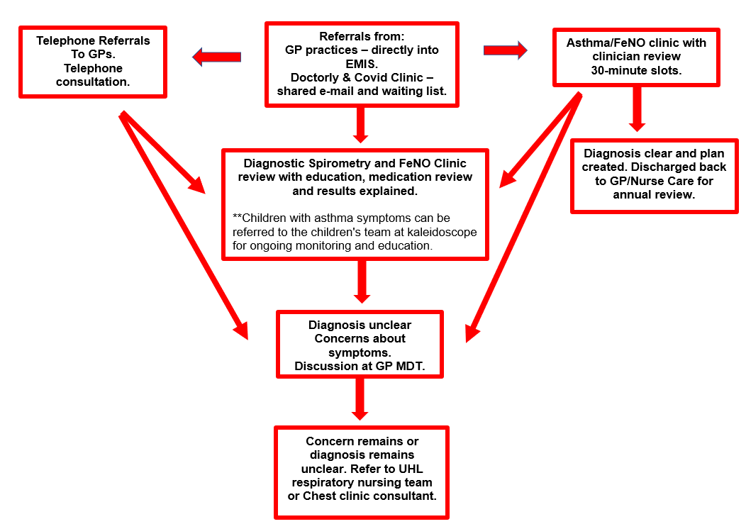
11.1. Appendix A: Patient referral pathway

11.2. Appendix B: Spirometry technician checklist

Contraindications for performing spirometry include:
- Haemoptysis of unknown origin. Yes/No
- Pneumothorax. Yes/No
- Pulmonary Embolism. Yes/No
- Unstable Cardiovascular statue. Yes/No
- Thoracic, abdominal or cerebral aneurysm (>6.5 cm). Yes/No
- Recent thoracic, abdominal or eye surgery. Less than 3 months. Yes/No
- Unknown TB status. Yes/No
- Cognitive impairment. Yes/No
- Pregnant. Yes/No

11.3. Appendix C: Clinic schedule
Day | Activity | Clinician
Monday | No Clinics
Tuesday | No Clinics
Wednesday  Marvels Lane  Waldron HC | - GP telephone clinic.  - FeNO clinic.  - Deteriorating patients and patients referred for review without spirometry.  - Post review telephone calls.  - Spirometry clinic.  - Post spirometry review. | - GP x 1  - Pharmacist x 1  - Clinical Lead Respiratory Hub x 1
Thursday | - Spirometry clinic.  - Post spirometry review. | - Clinical Lead Respiratory Hub x 1
Friday | - GP Doctaly telephone clinic.  - FeNO Clinic.  - Deteriorating patients and patients referred for review without spirometry.  - Spirometry clinic.  - Post spirometry review.  - F/up patient calls. | - GP x 1  - Nurse (09.30 – 17.00)  - Clinical Lead Respiratory Hub x 1

