The Health Innovation Network: Lived Experience Partners
Role description
November 2022

If you require this information in another format such as large print or easy read, please email: hin.involvement@nhs.net

Applying to be a Lived Experience Partner with the Health Innovation Network
We’re delighted you are interested in becoming a Lived Experience Partner with the Health Innovation Network (HIN).
The main experience we are looking for is personal experience of using health and/or social care services in south London – this may be for yourself, or as a carer. We also ask for a willingness to contribute to our work to improve health and care services through the spread of innovations.
We want to make sure we are hearing from people with lots of different health care experiences, and therefore welcome applications from everyone who this applies to.
We particularly encourage applications from people from ethnic minority backgrounds, people with disabilities, neurodivergent people, and members of the LGBTQ+ community. For this role, we are only able to work with people who are over the age of 18.
We want to make sure that this role is accessible. We will try to make reasonable adjustments you need to apply for the role, and to support you if you are successful. If you have any accessibility needs, please tell us about them in your application or contact us for help with your application.
Please read the role description below carefully to think about how you are right for the role. In your application, please answer both questions. All applications will be considered carefully, and we will use the information to shortlist for an interview.
We will be holding information webinars on Tuesday 8th November 12:30-13:00 or 18:00-18:30 as a chance to hear more about the role and to ask any questions you may have about the application process. These events are optional, and you do not need to attend both sessions.
Key Dates
Closing date for applications | Sunday 27th November at 18:00pm
Information webinars (repeated sessions) | Tuesday 8th November 12:30-13:00 or 18:00-18:30  Please email hin.involvement@nhs.net to access these sessions
Interviews (via zoom) | Wednesday 7th and Thursday 8th December 2022
If any of the dates above are not suitable for you, please contact hin.involvement@nhs.net and we will be as flexible as possible.
How to apply
Please complete and return the application form by email to: hin.involvement@nhs.net
You can choose to answer the questions in the application form either:
- in writing or
- as a short video or
- contact the team if you need to speak with them to take note of your answers over the telephone.
For more information, or if you need support to apply, contact the Involvement Team at hin.involvement@nhs.net
For more information about the HIN please visit our website: https://healthinnovationnetwork.com/
If you do not wish to apply at this time but would be interested in hearing about other involvement opportunities, please contact hin.involvement@nhs.net and request to be added to our mailing list.

Key information about the Lived Experience Partner role
What is the Lived Experience Partner role?
The HIN Lived Experience Partner is a paid role which will include:
- Working with HIN staff to advise on involvement activities in projects
- Reaching out to your networks to assist with recruitment of other people with lived experience to support our projects
- Collaborating with HIN staff to input your lived experience where it can best impact the organisation’s areas of work
- Supporting other people with lived experience who are involved in HIN projects
This is a role which will develop over time, and we want the people appointed to this role to help shape the role themselves based on their skills, experience and interests.

What are the skills and experience required for this role?
You will:
- Have personal experience of using health and care services in south London
- Be well connected to your local community particularly with those who have experience of using health and care services in south London
- Have experience of contributing to improvement of health and care services
- Have confidence to speak in meetings or to comment in meetings using the chat function or share views productively by other means of communication.
- Have excellent interpersonal skills and be comfortable working with a wide range of people at different levels of seniority and from different organisations
- Have the ability to show sound judgement and objectivity in order to represent wider views and experiences, not only your own.
- Have an awareness of, and commitment to, equality, diversity and inclusion.
- Understand the need for confidentiality.
- Feel comfortable in offering objective and constructive challenges.
Please note: we do not expect you to share personal details about your own health and/or healthcare experiences. This applies both for the application process and your involvement in the programme. However, you can share this information if you are comfortable to do so, where it could support the better understanding of the experiences of people living in south London and their engagement with healthcare services. Feel free to discuss with us how and when you might share your personal experiences.
What is ‘lived experience’ and who can apply?
Lived experience is personal knowledge about the world gained through direct, first-hand involvement in everyday events.
Anyone can apply who has lived experience of the health and care system in south London – either through personal use, or caring responsibilities.
What is the expected time requirement?
We are looking for people to support on average, one working day or 7.5 hours per week. The work is mainly expected to be within 09:00-17:00 Mon-Fri, but there may be activities outside of these hours.
Due to the nature of this work, the hours are likely to change from week to week, with some times being busier than others.
We will, however, work with closely you to ensure that the time required fits with your availability and any other existing commitments.
The role is initially until 31 March 2023, with a view to extending past this date for a one-year arrangement.
How many roles are available?
We currently have two roles available.
Will I need to travel?
Most of the work can be done online, however there may be times you wish to or need to come into the office (near London Bridge station) or attend events in south London.
If you are unable to travel due to mobility or other issues, alternative arrangements can be made.
What support is available to me when applying?
The HIN can:
- Help you to complete your application if needed.
- Provide you with information to help you feel prepared and comfortable to attend an interview if shortlisted (this includes sharing the interview questions in advance)
If I am successful, what support will be available to me?
We will discuss any support needs with you and will aim to meet these needs wherever possible. You will have an induction to the HIN and regular interaction with the involvement manager who can provide day to day support and guidance and will also work closely with the other lived experience partner who is appointed to this role.
Ongoing support and assistance to enable your involvement can be provided via:
- Documents shared and, if necessary, pre-meeting briefings will be provided wherever possible in advance of meetings.
- Meetings arranged around your availability as far as is possible.
- Support to enable you to contribute if you miss a meeting.
- Availability to address any questions you have.
- Check-in meetings or emails to hear your feedback and support your involvement.
- Access to learning and development opportunities.
If I am successful, how will I be paid?
If successful, you will employed by the HIN and paid for your time. The hourly rate will be the standard payment for Band 7 administrative and clerical staff. The work will be on average, 7.5 hours a week and you will be supported to join the Guy’s and St Thomas’ bank staff system for your payments to be processed. Payments will be made via this system to your bank account on a weekly basis, two weeks in arrears. There will be a requirement for you to provide timesheets to the Involvement Manager in order for these payments to be made.
If you would like to apply, but have a suggestion for another way this role could work (e.g. being paid via another organisation you currently support) please contact us.
We are very open to discuss other models and explore other ways payment for this work can be arranged so that the role works best for you. Please contact us via hin.involvement@nhs.net before applying to discuss this or any other payment queries you may have.

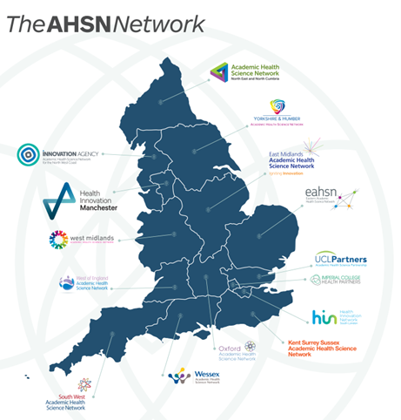
Further information
The Health Innovation Network
The Health Innovation Network (or HIN) is the Academic Health Science Network (AHSN) for south London. There are 15 AHSNs across England (see map for details). The aim of AHSNs, and the HIN, is to help health and care teams in south London benefit from new ideas, services, and technology faster, to improve care for the communities they serve.
Some of our work is funded through national commissioners including NHS England, the Office of Life Sciences, and the Patient Safety Commission. We are also supported by our members through direct contributions and are committed to delivering valuable services to them. In addition, we undertake work that is paid for by companies and organisations contributing to health. Our Executive team ensure that all our work supports our values and priorities, positively impacts the lives of south Londoners and contributes to the sustainability of our organisation.
As an organisation, we are hosted by Guy’s and St Thomas’ NHS Foundation Trust (GSTT), and work across the 12 boroughs of south London. The map below shows our area and the member organisations who we work closely with.
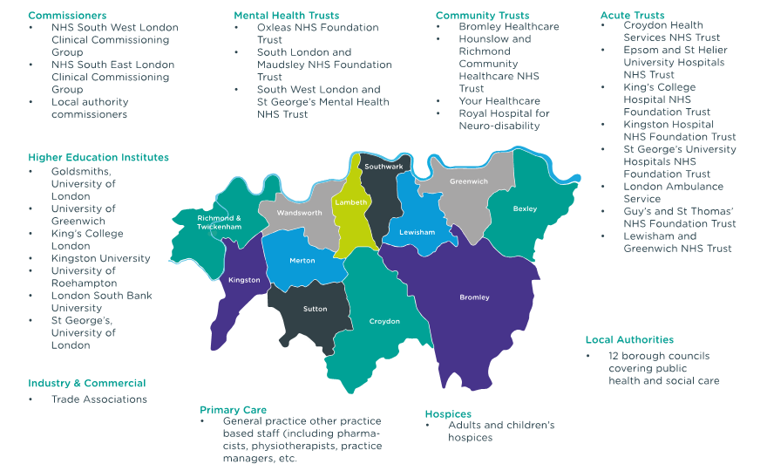
Our vision is: We want a future where health and care innovation spreads fast. We are building it by connecting people with great ideas, inspiring people to think differently, and giving them practical support to do something new. Together, we can create a future where everyone benefits from the best in health and care.
For more information about the HIN please visit our website: https://healthinnovationnetwork.com/

Involvement at the Health Innovation Network
At the HIN, we seek to understand, design, and improve the experience of health and care for staff, service users, and their families. We believe that this requires a deeper understanding, using people’s personal experiences to improve things.
To support this, we believe that we should actively be involving people in our work. Therefore, we have recently brought together over 65 people from across south London: people with lived experience of health and care, HIN colleagues, partners, and other stakeholders to co-design an Involvement Strategy for 2022-25.
As part of the strategy, we have developed several involvement principles, these are:
- Ensure that involving people is embedded in all our work.
- Embed our belief in equality, diversity, and inclusion in our approach to involving people.
- Extend the profile and influence of people’s voices in the decisions we make as an organisation.
- Build on our local connections and inspire more organisations and people to partner with us in our work.
- Demonstrate where involving people has made a positive difference.
If you would like a copy of our involvement strategy it can be found on the HIN website.
The lived experience partner role is part of our Involvement Strategy.

Our HIN Values
 | Value | HIN Value description | We have considered the HIN values and what they mean for involvement work …
 | Brave | We encourage our teams and others to be brave with their ideas and support them to try something new. | We encourage and support our colleagues to be open and willing to change as a result of involving people.
 | Kind | We care about each other, the people we work with, and about the health and wellbeing of south Londoners. | We care about our communities and want people to have a positive experience when they work with us.
 | Open | We are open about what we do, and we share what we learn. | We are open about what we do, and we continuously share what we learn with those who have been involved and helped us to make a difference.
 | Different | We think differently and we are strong because of our diverse backgrounds, talents, and experiences. | We find strength in our differences and are committed to involving people with a multitude of perspectives so that we can identify areas to improve and try new things.
 | Together | We build communities and networks, we collaborate, and we connect. | Our core belief is that we can close the health inequalities gap by including diverse communities in the design and development of innovations.

Next steps
Once we receive your application, the steps will be:
- We will let you know we have received your application form via email. If you do not receive a response from us to confirm receipt within three days, please get in touch.
- Interviews will take place via teleconference (Zoom) on the 7th and 8th December 2022.
- We will need two references for successful applicants before the role can begin. These can be personal (friend or family) or work references.
- We will reply to everyone who sends us an application, to let you know if you have been successful or unsuccessful in being invited to interview.
- Emails to successful applicants will include information about next steps.

If you do not wish to apply at this time but would be interested in hearing about other involvement opportunities, please contact hin.involvement@nhs.net and request to be added to our mailing list.
If you have any questions about the application process, or would like an informal chat about the opportunity – please contact hin.involvement@nhs.net

